

December 1, 2015

Health Services Cost Review Commission

4160 Patterson Avenue

Baltimore, MD 21215

To Whom It May Concern:

Enclosed is a report outlining Adventist HealthCare Behavioral Health & Wellness Services’ plans to reduce readmissions and other avoidable utilization.

If you need any additional information, please contact me at 301-251-4644.

Respectfully submitted,

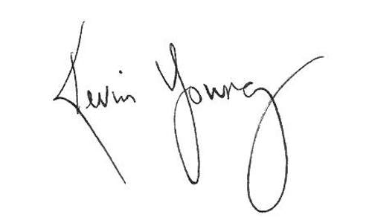

Kevin Young, FACHE

President

Adventist HealthCare Behavioral Health & Wellness Services