HSCRC Transformation Grant
  - FY 2018 Report
The Health Services Cost Review Commission (HSCRC) is reviewing the following for FY 2018: this Report, the Budget Report, and the Budget Narrative. Whereas the Budget Report distinguishes between each hospital, this Summary Report should describe all hospitals, if more than one, that are in the Regional Partnership.

Regional Partnership Information
Regional Partnership (RP) Name | Peninsula Regional Medical Center
RP Hospital(s) | Peninsula Regional Medical Center, Atlantic General Hospital, McCready Hospital
RP POC | Kathryn Fiddler
RP Interventions in FY 2018 | Care Coordination, Smith Island Telehealth, Wagner Wellness Van
Total Budget in FY 2018  This should equate to total FY 2017 award | FY 2018 Award: See budget Worksheets
Total FTEs in FY 2018 | 24.2
 | Contracted: None
Program Partners in FY 2018  Please list any community-based organizations or provider groups, contractors, and/or public partners | Peninsula Regional Medical Center; Atlantic General Hospital; McCready Health; MAC – Area Agency on Aging; Wicomico County Health Department; Worcester County Health Department; Somerset County Health Department; City of Salisbury; Halo shelter; HOPE, Inc; Salisbury Urban Ministries; St. James AME Church; St. Paul’s AME Church; St. Peter’s Catholic Church; Somerset County Library; Chesapeake Health Center; Community Foundation of the Eastern Shore; Resource & Recovery Center; National Kidney Foundation, Salisbury Fire Department

Overall Summary of Regional Partnership Activities in FY 2018
For this regional partnership, FY 2018 was the first full year of activities related to the HSCRC grant. We worked on three projects, Collaborative Care Coordination, Smith Island Telehealth, and Wagner Wellness Van.

Intervention Program
Please copy/paste this section for each Intervention/Program that your Partnership maintains, if more than one.
Intervention or Program Name | Wagner Wellness Van
RP Hospitals Participating in Intervention  Please indicate if All; otherwise, please indicate which of the RP Hospitals are participating. | Peninsula Regional Medical Center; Atlantic General Hospital; McCready Health
Brief description of the Intervention  2-3 sentences | Mobile clinic visiting locations in three counties utilizing staff from all three hospitals. Services include screenings and assessments; chronic disease education & prevention strategies; connection with primary care and community resources; and sick visits and follow-up visits with a nurse practitioner. Additional NP and RN duties extended to our Mobile Integrated Health program (Salisbury/Wicomico Integrated Firstcare Team – SWIFT). Through that program, the van staff teamed up with EMS to provide home visits; resource connection, and care coordination for high utilizers of the EMS system.
Participating Program Partners  Please list the relevant community-based organizations or provider groups, contractors, and/or public partners | Peninsula Regional Medical Center; Atlantic General Hospital; McCready Health; MAC – Area Agency on Aging; Wicomico County Health Department; Worcester County Health Department; Somerset County Health Department; City of Salisbury; Halo shelter; HOPE, Inc; Salisbury Urban Ministries; St. James AME Church; St. Paul’s AME Church; St. Peter’s Catholic Church; Somerset County Library; Chesapeake Health Center; Community Foundation of the Eastern Shore; Resource & Recovery Center; National Kidney Foundation, Salisbury Fire Department
Patients Served  Please estimate using the Population category that best applies to the Intervention, from the CY 2017 RP Analytic Files.  HSCRC acknowledges that the High Utilizer/Rising Risk or Payer designations may over-state the population, or may not entirely represent this intervention’s targeted population.  Feel free to also include your partnership’s denominator. | # of Patients Served as of June 30, 2018:  845 (July 1, 2017 – June 30, 3018)  48 for SWIFT (October 1, 2017 – June 30, 2018)
Denominator of Eligible Patients VAN: 71,058

The Wagner Van is intended to meet the needs of individuals lacking access to care and/or without mechanism to pay. Data from the RP analytical files does not provide visibility to this information. All payer patient numbers were used as the denominator in absence of any other relevant number

Denominator for Eligible Patients High Risk Care Coordination programs (AGH/WorCty HD and PRMC - SWIFT): 1472
Pre-Post Analysis for Intervention (optional)  If available, RPs may submit a screenshot or other file format of the Intervention’s Pre-Post Analysis. | See Appendix 1 - Screen Shot attached for the SWIFT program (ED and 911 high utilizers)  Screen shot Embedded Care Coordinators
Intervention-Specific Outcome or Process Measures  (optional)  These are measures that may not have generic definitions across Partnerships or Interventions and that your Partnership maintains and uses to analyze performance.  Examples may include: Patient satisfaction; % of referred patients who received Intervention; operationalized care teams; etc. | Evidence Based Programs supported by the Grant: 500 Community members on the Lower Eastern Shore attending classes for PEARLS, CDSM, Stepping On, and Stepping up your nutrition (See documents attached Appendix 2).  Data in Appendix 2 provides information on program completion rates,
Successes of the Intervention in FY 2018  Free Response, up to 1 Paragraph | Through our tri-county mobile outreach, we interacted with approximately 340 community members who did not have a Primary Care Provider. We provided each of them with a list of PCPs in the community, and we actually made appointments for many of the patients – particularly those who screened positive for HTN or DM or who we were seeing for a sick visit with the NP.
Lessons Learned from the Intervention in FY 2018  Free Response, up to 1 Paragraph | The biggest lesson learned is that there needs to be external forces working to drive patients to the mobile clinic. Parking it and expecting people to come does not yield the volumes one would anticipate. Having a process for referral to the clinic by various organizations has proven to be the most beneficial way to impact subsets of the population in the community. Examples would include Medication Assisted Therapy patients from the health departments; uninsured patients from the ED (for follow up and resource connection); homeless clients with no transportation/insurance/PCP from the shelters; undocumented patients from the community; etc.
Next Steps for the Intervention in FY 2019  Free Response, up to 1 Paragraph | Next steps for the Intervention will include targeted health fairs to areas of the Shore with limited access to care. These health fairs will afford an opportunity to interact with community members about their health, while providing valuable data about the health of a community to guide targeted interventions. For example, a health fair held in Smith Island, Md, demonstrated that 50% of participants there had an A1C >6.5, compared with 22% of mainland participants. Other plans for the mobile outreach clinic include exploration of telemedicine to facilitate provider visits and integration with other hospital and/or community programs that increase access to care and community care coordination.
Additional Free Response (Optional)

Intervention or Program Name | Community Care Coordination
RP Hospitals Participating in Intervention  Please indicate if All; otherwise, please indicate which of the RP Hospitals are participating. | Peninsula Regional Medical Center; Atlantic General Hospital; McCready Health
Brief description of the Intervention  2-3 sentences | Coordination for high risk individuals within the three hospitals utilizing care coordination teams, local community agencies, and Community Evidence Based Classes in an effort to reduce unnecessary utilization and improve support for high risk individuals,
Participating Program Partners  Please list the relevant community-based organizations or provider groups, contractors, and/or public partners | Peninsula Regional Medical Center; Atlantic General Hospital; McCready Health; MAC – Area Agency on Aging; Wicomico County Health Department; Worcester County Health Department; Somerset County Health Department; City of Salisbury; Chesapeake Health Center; Salisbury Fire Department
Patients Served  Please estimate using the Population category that best applies to the Intervention, from the CY 2017 RP Analytic Files.  HSCRC acknowledges that the High Utilizer/Rising Risk or Payer designations may over-state the population, or may not entirely represent this intervention’s targeted population.  Feel free to also include your partnership’s denominator. | # of Patients Served as of June 30, 2018:  1283 Pts with Care Coordination  500 Community Based Educational Classes
 | Denominator for Eligible Patients High Risk Care Coordination programs (AGH/WorCty HD and PRMC - SWIFT): 5213
Pre-Post Analysis for Intervention (optional)  If available, RPs may submit a screenshot or other file format of the Intervention’s Pre-Post Analysis. | See Appendix 1 - Screen Shot attached for the SWIFT program (ED and 911 high utilizers)  Screen shot Embedded Care Coordinators
Intervention-Specific Outcome or Process Measures  (optional)  These are measures that may not have generic definitions across Partnerships or Interventions and that your Partnership maintains and uses to analyze performance.  Examples may include: Patient satisfaction; % of referred patients who received Intervention; operationalized care teams; etc. | Evidence Based Programs supported by the Grant: 500 Community members on the Lower Eastern Shore attending classes for PEARLS, CDSM, Stepping On, and Stepping up your nutrition (See documents attached Appendix 2).  Data in Appendix 2 provides information on program completion rates, patient satisfaction and health improvement outcomes measures
Successes of the Intervention in FY 2018  Free Response, up to 1 Paragraph | For each organization and collaboratively we have improved care coordination as evidenced by generation of CRISP care alerts, with 52.3% of all high-risk patients, and 12% of rising needs patients. All three organizations have worked collaboratively to share best practices, improve communication among teams and providers as well as community post-acute care partners.
Lessons Learned from the Intervention in FY 2018
Free Response, up to 1 Paragraph
Next Steps for the Intervention in FY 2019  Free Response, up to 1 Paragraph | Future efforts: expanding access to healthcare services, deploying outpatient Supportive Care and Pain Management programs, and strengthening transitions of care.  - Pain Rehabilitation Program – September 2018- Program identifies those patients with chronic pain and the complete a two week outpatient program including physical rehabilitation, emotional, educational, and behavioral and peer support and extensive education on alternatives to learn to minimize pain and live a quality life with chronic pain.  - Regional efforts to address patients with rising risk of end stage renal disease- October 2018 will be the first regional meeting although individual efforts have occurred, this will be a more organized and strategic partnership with the providers.  - Expansion of outpatient supportive care services to include patients with chronic disease in addition to cancer starting fall 2018.  - Development of more telehealth and remote patient monitoring to high risk patients within the tri-county area
Additional Free Response (Optional)
Intervention or Program Name | Smith Island Telehealth
RP Hospitals Participating in Intervention  Please indicate if All; otherwise, please indicate which of the RP Hospitals are participating. | Peninsula Regional Medical Center; McCready Health
Brief description of the Intervention  2-3 sentences | Smith Island community health worker staff provide chronic disease educational support and connection to telehealth for primary care to island resident of Smith Island, MD
Participating Program Partners  Please list the relevant community-based organizations or provider groups, contractors, and/or public partners | Peninsula Regional Medical Center; McCready Health; MAC – Area Agency on Aging; Somerset County Health Department, Crisfield Clinic
Patients Served  Please estimate using the Population category that best applies to the Intervention, from the CY 2017 RP Analytic Files.  HSCRC acknowledges that the High Utilizer/Rising Risk or Payer designations may over-state the population, or may not entirely represent this intervention’s targeted population.  Feel free to also include your partnership’s denominator. | # of Patients Served as of June 30, 2018: 98
 | Denominator of Eligible Patients: 250
Pre-Post Analysis for Intervention (optional)  If available, RPs may submit a screenshot or other file format of the Intervention’s Pre-Post Analysis. | N/A
Intervention-Specific Outcome or Process Measures  (optional)  These are measures that may not have generic definitions across Partnerships or Interventions and that your Partnership maintains and uses to analyze performance.  Examples may include: Patient satisfaction; % of referred patients who received Intervention; operationalized care teams; etc. | N/A
Successes of the Intervention in FY 2018  Free Response, up to 1 Paragraph | Having CHW’s that are trusted Island residents has proven to be the key for this population. Their ability to influence behaviors and actions in their community members is paramount to the project, and something that “outsiders” would likely not be able to achieve. Examples include: blood sugar reduction in a husband and wife from 300s to 120s; ED avoidance by a habitual user of the ED, opting to receive care on the Island; improvement in the understanding of and compliance with medications; and increased knowledge regarding causes and management of chronic disease.
Lessons Learned from the Intervention in FY 2018  Free Response, up to 1 Paragraph | The people of Smith Island are very loyal, hard-working people. Their culture can be difficult to understand. However, it must be understood and considered in order to have a successful program. Cultures and relationships outside of the Island have also proven to be factors influencing the success of the Intervention. Concessions that account for these relationships, cultures, and idiosyncrasies have been and will continue to be necessary going forward.
Next Steps for the Intervention in FY 2019  Free Response, up to 1 Paragraph | Next steps include certification of the CHW’s in CDSME to afford Islanders the opportunity to participate in self-management classes in their community. Exercise equipment is now on both islands for use by the residents. Walking clubs complete with marked paths, walk journals, pedometers, and incentive “prizes” will be added in the Fall. Given the success of the first health fair, we are planning another event for FY ’19. Additionally, we will continue to work toward the goal of adding other PCP’s and specialists to the list of Telemedicine providers for Smith Island.
Additional Free Response (Optional) | There was a 5% reduction in ED utilization at McCready Hospital for patients with a Smith Island zip code from the time the initiative started in October, 2017, to the end of FY 2018, compared to the same amount of time pre-October, 2017.

Core Measures
Please fill in this information with the latest available data from the in the CRS Portal Tools for Regional Partnerships. For each measure, specific data sources are suggested for your use– the Executive Dashboard for Regional Partnerships, or the CY 2017 RP Analytic File (please specify which source you are using for each of the outcome measures).

Utilization Measures
Measure in RFP  (Table 1, Appendix A of the RFP) | Measure for FY 2018 Reporting | Outcomes(s)
Total Hospital Cost per capita | Partnership IP Charges per capita  Executive Dashboard:  ‘Regional Partnership per Capita Utilization’ –  Hospital Charges per Capita, reported as average 12 months of CY 2017  -or-  Analytic File:  ‘Charges’ over ‘Population’  (Column E / Column C) | POP Category Per capita Charges  2+ Chronic Conditions and Medicare FFS $ 5,370.94  2+ IP or Obs>=24 or ED Visits $ 1,645.05  2+ IP or Obs>=24 or ED Visits Medicare FFS $ 3,857.89  3+ IP or Obs>=24 Visits $ 560.42  3+ IP or Obs>=24 Visits Medicare FFS $ 1,586.50  All Payer $ 2,151.36  All Payer $ 1,028.63  All Payer $ 3,260.49  Medicare FFS $ 5,952.70
Total Hospital Discharges per capita | Total Discharges per 1,000 | Hospital Discharges per 1000 = 7
Total Health Care Cost per person | Partnership TCOC per capita – Medicare  Total Cost of Care (Medicare CCW) Report ‘Regional Partnership Cost of Care’:  ‘Tab 4. PBPY Costs by Service Type’ – sorted for CY 2017 and Total | 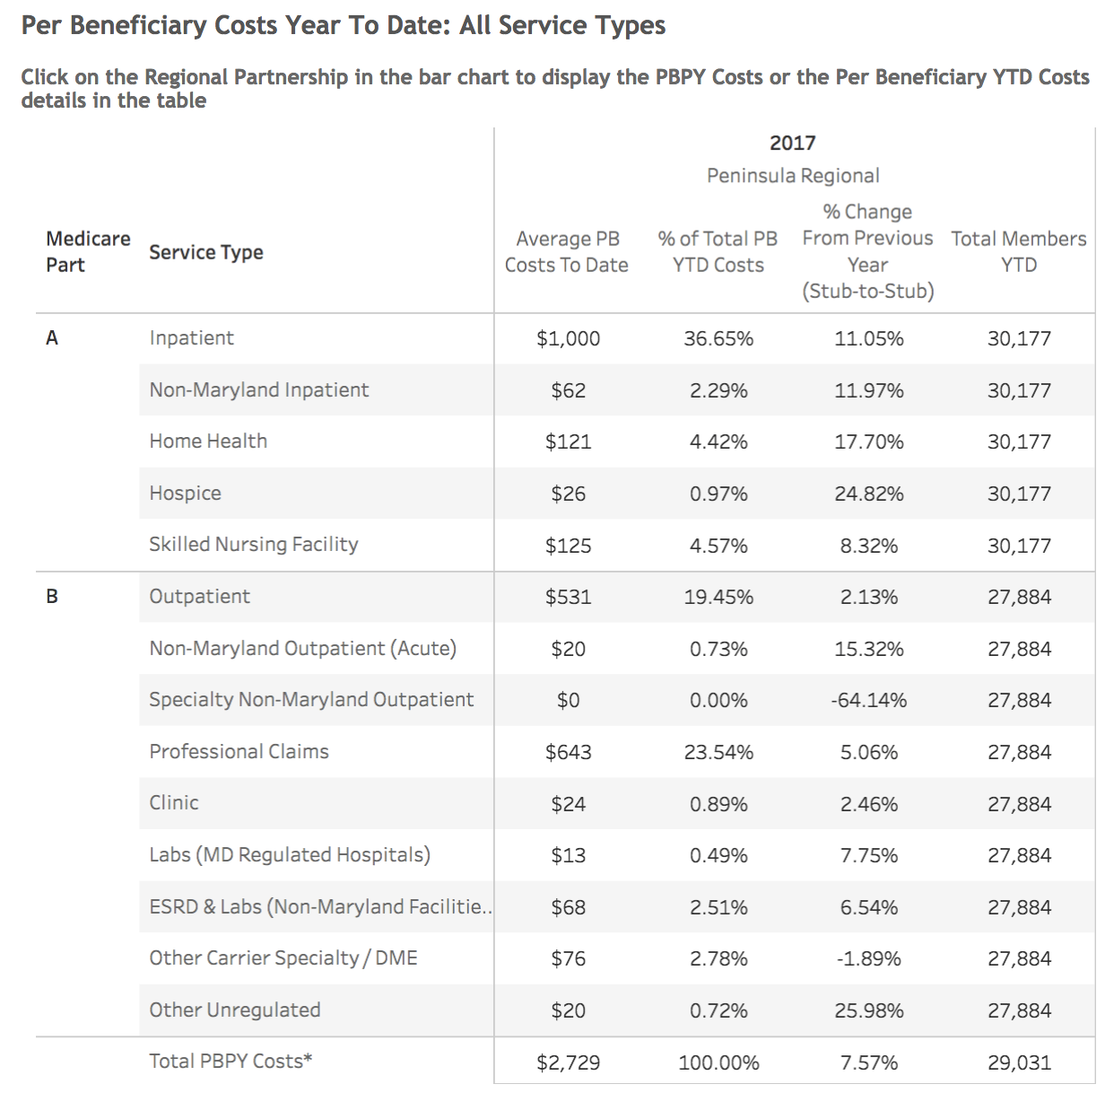
ED Visits per capita | Ambulatory ED Visits per 1,000 | ED Visits per 1000 = 40

Quality Indicator Measures
Measure in RFP  (Table 1 in Appendix A of the RFP) | Measure for FY 2018 Reporting | Outcomes(s)
Readmissions | Unadjusted Readmission rate by Hospital (please be sure to filter to include all hospitals in your RP)  Analytic File:  ‘IP Readmit’ over ‘EligibleforReadmit’  (Column J / Column I) | Unadjusted readmission rate all three hospitals: 12.29% for 2018
PAU | Potentially Avoidable Utilization  Executive Dashboard:  ‘[Partnership] Quality Indicators’ –  Potentially Avoidable Utilization, reported as sum of 12 months of FY 2018  -or-  Analytic File:  ‘TotalPAUCharges’  (Column K) | Total PAU Charges -  $28,343,544.15

CRISP Key Indicators (Optional)
These process measures tracked by the CRISP Key Indicators are new, and HSCRC anticipates that these data will become more meaningful in future years.
Measure in RFP  (Table 1 in Appendix A of the RFP) | Measure for FY 2018 Reporting | Outcomes(s)
Established Longitudinal Care Plan | % of patients with Care Plan recorded at CRISP  Executive Dashboard:  ‘High Needs Patients – CRISP Key Indicators’ –  % of patients with Care Plan recorded at CRISP, reported as average monthly % for most recent six months of data  May also include Rising Needs Patients, if applicable in Partnership. | N/A Organizations have no ability to submit Care Plans to CRISP via AllScripts/EPIC at this time
Portion of Target Population with Contact from Assigned Care Manager | Potentially Avoidable Utilization  Executive Dashboard:  ‘High Needs Patients – CRISP Key Indicators’ –  % of patients with Case Manager (CM) recorded at CRISP, reported as average monthly % for most recent six months of data  May also include Rising Needs Patients, if applicable in Partnership. | 55.1% of High Needs patients have a Case Mgr recorded at CRISP

Self-Reported Process Measures
Please describe any partnership-level process measures that your RP may be tracking but are not currently captured under the Executive Dashboard. Some examples are shared care plans, health risk assessments, patients with care manager who are not recorded in CRISP, etc.

Wagner Wellness Van Self-reported Measures

Hypertension screening – 845
Diabetes screening – 392
Referral to PCP – 340
EMS/911 calls by SWIFT patients – reduced by 70% first 6 months (October 2017 – April 2018

Return on Investment
ROI is presently calculated through utilization of the Pre and Post Analysis data in CRISP and in data on compliance with chronic disease management through Evidence based programs.

Conclusion
Please include any additional information you wish to share here. Free Response, 1-3 Paragraphs.

Appendix 1:

SWIFT Program Pre-Post Analysis

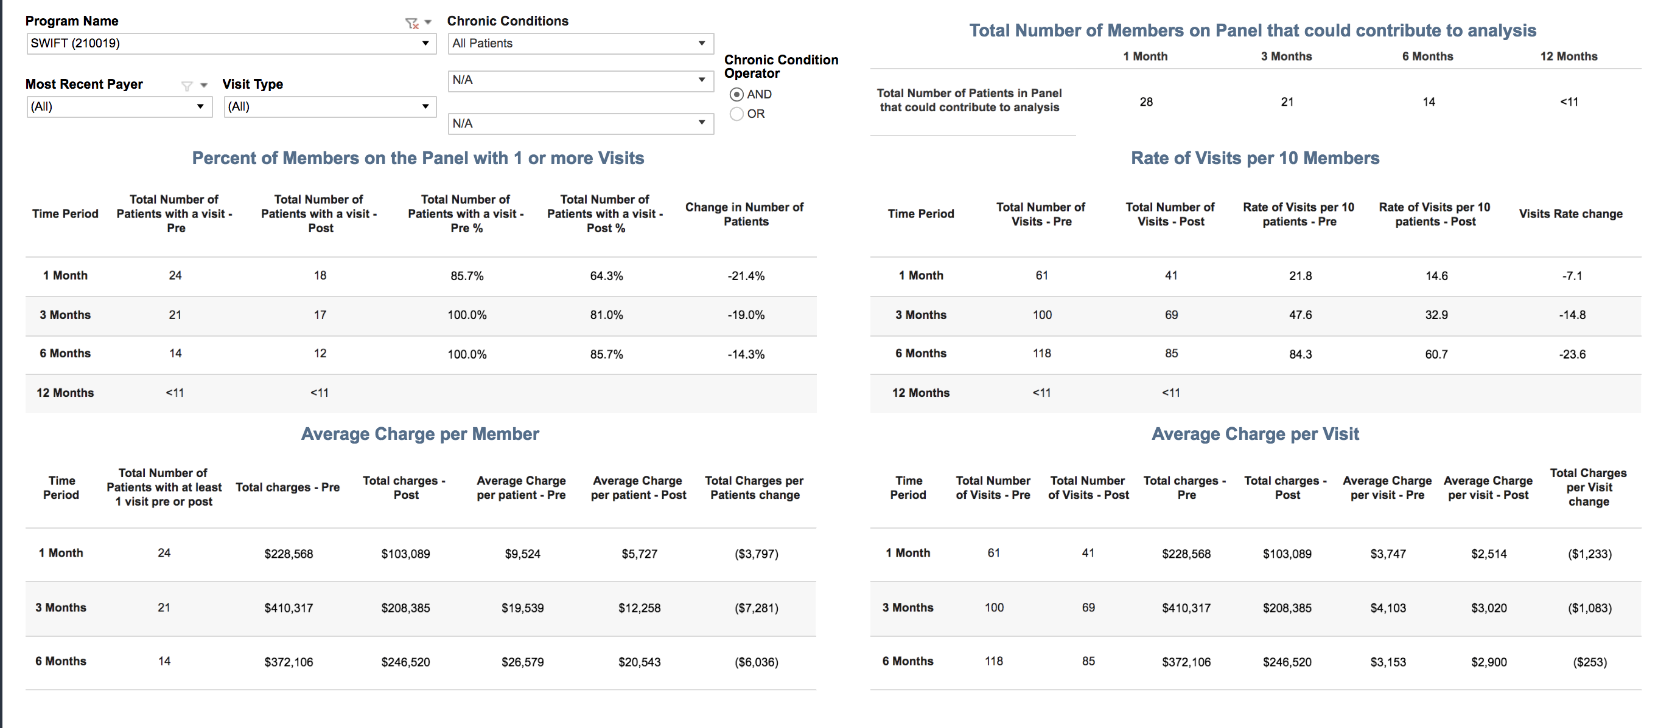
Embedded Care Coordinators Pre-Post Analysis FY 2018
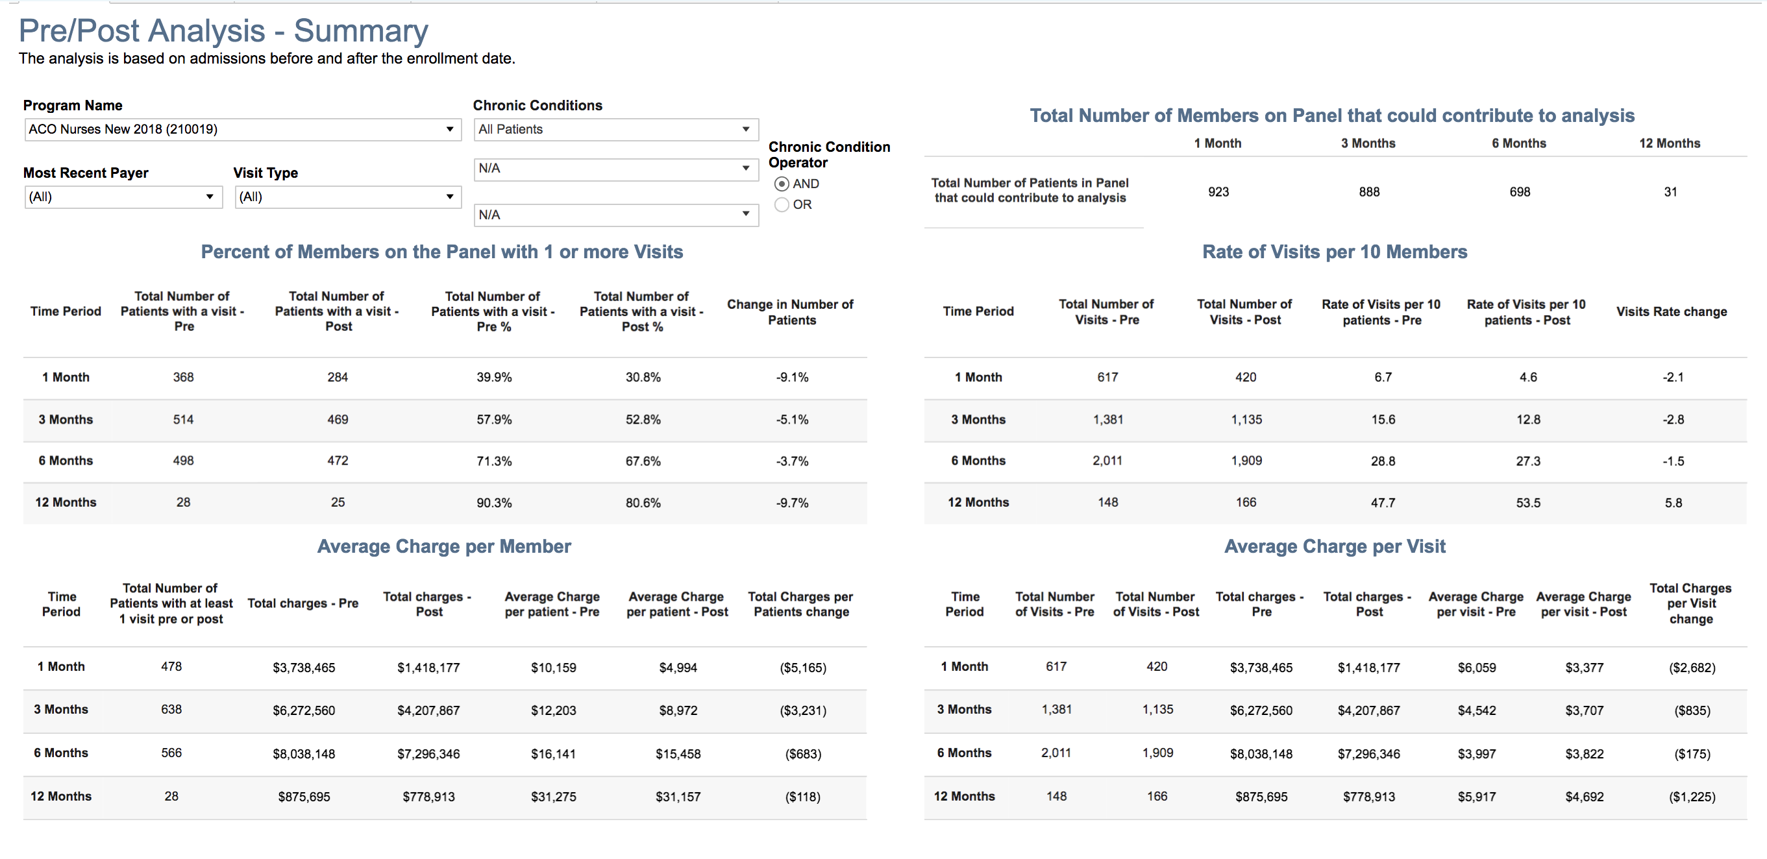

MAC Inc.
Chronic Disease Self-Management
(CDSME)

7/1/17 - 6/30/18
Number of workshops: 14

Average participants per workshop: 9.5
Number of participants: 133
Participants with attendance data: 133
Completers: 120 of 133 (90%)
Number who are caregivers: 25 of 104 (24%)
Age | Count | Percent | Bar
0-44 | 5 | 5% | ......
44-49 | 1 | 1% | ..
50-54 | 2 | 2% | ...
55-59 | 7 | 7% | ........
60-64 | 15 | 14% | ...............
65-69 | 26 | 24% | .........................
70-74 | 14 | 13% | ..............
75-79 | 17 | 16% | .................
80-84 | 9 | 8% | .........
85-89 | 5 | 5% | ......
90+ | 6 | 6% | .......
Unknown | 26

Can Manage Condition | Count | Percent | Bar
8 | 21 | 40% | .........................................
10 | 14 | 26% | ...........................
9 | 12 | 23% | ........................
7 | 4 | 8% | .........
6 | 2 | 4% | .....
Unknown | 80

Caregiver | Count | Percent | Bar
No | 79 | 76% | .............................................................................
Yes | 25 | 24% | .........................
Unknown | 29

Chronic Condition | Count | Percent | Bar
Hypertension | 68 | 67% | ....................................................................
Diabetes | 59 | 58% | ...........................................................
Arthritis | 42 | 41% | ..........................................
Cancer | 24 | 24% | .........................
Osteoporosis | 22 | 22% | .......................
Obesity | 20 | 20% | .....................
Heart Disease | 19 | 19% | ....................
Lung Disease | 18 | 18% | ...................
Depression or Mental Illness | 17 | 17% | ..................
Chronic Pain | 14 | 14% | ...............
Kidney Disease | 9 | 9% | ..........
Stroke | 8 | 8% | .........
Schizophrenia | 2 | 2% | ...
Other | 3 | 3% | ....
Unknown | 6

Completers | Count | Percent | Bar
Yes | 120 | 90% | ...........................................................................................
No | 13 | 10% | ...........

Condition Count | Count | Percent | Bar
Multiple chronic conditions | 86 | 68% | .....................................................................
No chronic conditions | 25 | 20% | .....................
One chronic condition | 16 | 13% | ..............
Unknown | 6

Disabilities | Count | Percent | Bar
Limited Phy/Men/Emotion | 18 | 14% | ...............
Visually impaired | 10 | 8% | .........
Hearing impaired | 10 | 8% | .........
Diff. walking or climbing stairs | 2 | 2% | ...

Education | Count | Percent | Bar
Completed High School | 29 | 29% | ..............................
Completed College | 28 | 28% | .............................
Some College | 27 | 27% | ............................
Some High School | 16 | 16% | .................
Unknown | 33

Ethnicity/Race | Count | Percent | Bar
White/Caucasian | 57 | 53% | ......................................................
Black or African American | 48 | 44% | .............................................
American Indian or AK Native | 6 | 6% | .......
Hispanic/Latino | 6 | 6% | .......
Asian or Asian American | 3 | 3% | ....
Hawaiian Native or Pacific Islander | 1 | 1% | ..
Unknown | 25

Gender | Count | Percent | Bar
Female | 104 | 79% | ................................................................................
Male | 27 | 21% | ......................
Unknown | 2

Health | Count | Percent | Bar
Good | 53 | 55% | ........................................................
Fair | 21 | 22% | .......................
Very Good | 16 | 16% | .................
Excellent | 4 | 4% | .....
Poor | 3 | 3% | ....
Unknown | 36

How Did You Hear | Count | Percent | Bar
Not reported | 133 | 100% | .....................................................................................................

Insurance | Count | Percent | Bar
Medicare | 54 | 75% | ............................................................................
BC/BS | 13 | 18% | ...................
Medicaid | 10 | 14% | ...............
United | 9 | 12% | .............
Aetna | 5 | 7% | ........
Humana | 3 | 4% | .....
No Insurance | 2 | 3% | ....
AARP | 1 | 1% | ..
EHP - Johns Hopkins | 1 | 1% | ..
Veterans Health | 1 | 1% | ..
Mutual of Omaha | 1 | 1% | ..
Other | 10 | 14% | ...............
Unknown | 61

Lives Alone | Count | Percent | Bar
No | 62 | 62% | ...............................................................
Yes | 38 | 38% | .......................................
Unknown | 33

Organization | Count | Percent | Bar
MAC Inc | 133 | 100% | .....................................................................................................

Participant County | Count | Percent | Bar
Wicomico, MD | 48 | 36% | .....................................
Worcester, MD | 26 | 20% | .....................
Somerset, MD | 23 | 17% | ..................
Dorchester, MD | 12 | 9% | ..........
Queen Annes, MD | 12 | 9% | ..........
Sussex, DE | 8 | 6% | .......
Kent, MD | 2 | 2% | ...
Caroline, MD | 2 | 2% | ...

I have more self-confidence in my ability to manage my health than I did before taking this workshop | Count | Percent | Bar
Strongly Agree (1) | 54 | 81%
Agree (2) | 13 | 19%
Average Value | 1.2

The book that we used for the workshop was very helpful | Count | Percent | Bar
Strongly Agree (1) | 56 | 84%
Agree (2) | 10 | 15%
Disagree (3) | 1 | 1%
Average Value | 1.2

I learned how to set an action plan and follow it | Count | Percent | Bar
Strongly Agree (1) | 53 | 79%
Agree (2) | 14 | 21%
Average Value | 1.2

I now have a better understanding of how to manage the symptoms of my chronic health conditions | Count | Percent | Bar
Strongly Agree (1) | 48 | 72%
Agree (2) | 18 | 27%
Disagree (3) | 1 | 1%
Average Value | 1.3

The site used for the workshop was conducive to learning | Count | Percent | Bar
Strongly Agree (1) | 52 | 79%
Agree (2) | 14 | 21%
Average Value | 1.2

I felt my opinions and contributions to the group were valued by the other participants | Count | Percent | Bar
Strongly Agree (1) | 51 | 76%
Agree (2) | 16 | 24%
Average Value | 1.2

The peer leaders were able to manage the group very well | Count | Percent | Bar
Strongly Agree (1) | 59 | 88%
Agree (2) | 8 | 12%
Average Value | 1.1

I felt my opinions and contributions to the group were valued by the peer leaders | Count | Percent | Bar
Strongly Agree (1) | 55 | 82%
Agree (2) | 12 | 18%
Average Value | 1.2

My peer leaders got along well together | Count | Percent | Bar
Strongly Agree (1) | 59 | 88%
Agree (2) | 8 | 12%
Average Value | 1.1

I valued the time to talk to other participants at break time | Count | Percent | Bar
Strongly Agree (1) | 50 | 75%
Agree (2) | 17 | 25%
Average Value | 1.3

I noticed that some participants did not come back to the workshop after the first week | Count | Percent | Bar
Strongly Agree (1) | 12 | 19%
Agree (2) | 28 | 45%
Disagree (3) | 14 | 23%
Strongly Disagree (4) | 8 | 13%
Average Value | 2.3

I feel more motivated to take care of my health since I took this workshop | Count | Percent | Bar
Strongly Agree (1) | 51 | 77%
Agree (2) | 13 | 20%
Disagree (3) | 1 | 2%
Strongly Disagree (4) | 1 | 2%
Average Value | 1.3

MAC Inc.
Stepping Up Your Nutrition (SUYN)
7/1/17 - 6/30/18
Number of workshops: 9

Average participants per workshop: 8.9
Number of participants: 80
Participants with attendance data: 0
Completers: 0 of 0
Number who are caregivers: 0 of 0
Age | Count | Percent | Bar
60-64 | 1 | 14% | ...............
70-74 | 1 | 14% | ...............
75-79 | 1 | 14% | ...............
80-84 | 1 | 14% | ...............
85-89 | 3 | 43% | ............................................
Unknown | 73

Chronic Condition | Count | Percent | Bar
Arthritis | 10 | 77% | ..............................................................................
Diabetes | 5 | 38% | .......................................
Heart Disease | 4 | 31% | ................................
Lung Disease | 2 | 15% | ................
Hypertension | 1 | 8% | .........
Cancer | 1 | 8% | .........
Depression or Mental Illness | 1 | 8% | .........
Other | 9 | 69% | ......................................................................

Completers | Count | Percent | Bar
No | 80 | 100% | .....................................................................................................

Condition Count | Count | Percent | Bar
No chronic conditions | 67 | 84% | .....................................................................................
Multiple chronic conditions | 11 | 14% | ...............
One chronic condition | 2 | 2% | ...

Disabilities | Count | Percent | Bar
Limited Phy/Men/Emotial | 4 | 5% | ......

Education | Count | Percent | Bar
Completed High School | 7 | 41% | ..........................................
Some High School | 6 | 35% | ....................................
Some College | 3 | 18% | ...................
Completed College | 1 | 6% | .......
Unknown | 63

Ethnicity/Race | Count | Percent | Bar
Black or African American | 12 | 71% | ........................................................................
White/Caucasian | 5 | 29% | ..............................
Unknown | 63

Gender | Count | Percent | Bar
Female | 69 | 86% | .......................................................................................
Male | 11 | 14% | ...............

How Did You Hear | Count | Percent | Bar
Not reported | 80 | 100% | .....................................................................................................

Insurance | Count | Percent | Bar
Medicare | 5 | 100% | .....................................................................................................
United | 1 | 20% | .....................
BC/BS | 1 | 20% | .....................
United American, Humana | 1 | 20% | .....................
Other | 1 | 20% | .....................
Unknown | 75

Lives Alone | Count | Percent | Bar
Yes | 13 | 100% | .....................................................................................................
Unknown | 67

Organization | Count | Percent | Bar
MAC Inc | 80 | 100% | .....................................................................................................

Participant County | Count | Percent | Bar
Wicomico, MD | 46 | 58% | ...........................................................
Somerset, MD | 12 | 15% | ................
Dorchester, MD | 12 | 15% | ................
Worcester, MD | 10 | 12% | .............

People in Household | Count | Percent | Bar
1 | 13 | 100% | .....................................................................................................
Unknown | 67

Referred | Count | Percent | Bar
No | 80 | 100% | .....................................................................................................

What year were you born?
Average Value | 1943.2

Are you Male or Female | Count | Percent
Male (1) | 8 | 11%
Female (2) | 66 | 89%
Average Value | 1.9

In the past 3 months, how many times have you fallen?
Average Value | 0.3

If you fell in the past 3 months, how many of these falls caused an injury? (By an injury we mean the fall caused you to limit your regular activities for at least a day or to go see a doctor)?
Average Value | 0.1

Number of falls within the past 3 months | Count | Percent
0 (1) | 53 | 83%
1 (2) | 4 | 6%
2-4 (3) | 7 | 11%
Average Value | 1.3

Number of falls causing injury past 3 months | Count | Percent
0 (1) | 57 | 89%
1 (2) | 5 | 8%
2-4 (3) | 2 | 3%
Average Value | 1.1

How fearful are you of falling? | Count | Percent
Not at all (1) | 17 | 26%
A little (2) | 22 | 34%
Somewhat (3) | 20 | 31%
A lot (4) | 6 | 9%
Average Value | 2.2

Has your weight changed in the past 30 days? | Pre | Post
Yes, gained weight (1) | 9% | 33%
No, weight stayed the same (2) | 76% | 33%
Yes, lost weight (3) | 15% | 33%
Average Value | 2.1 | 2

Have you been trying to change your weight in past 30 days? | Pre | Post
Yes (1) | 33% | 67%
No (2) | 66% | 33%
No, changed anyway (3) | 2% | 0%
Average Value | 1.7 | 1.3

How would you describe your appetite? | Pre | Post
Very good (1) | 62% | 67%
Good Fair (2) | 36% | 33%
Poor (3) | 2% | 0%
Average Value | 1.4 | 1.3

Do you eat one or more meals a day with someone? | Pre | Post
Never or rarely (1) | 23% | 0%
Sometimes (2) | 42% | 100%
Often (3) | 12% | 0%
Almost always (4) | 23% | 0%
Average Value | 2.4 | 2

Do you have any problems getting your groceries? Problems can be poor health or disability, limited income, lack of transportation, weather conditions, or finding someone to shop. | Pre | Post
Never or rarely (1) | 90% | 100%
Sometimes (2) | 8% | 0%
Always (4) | 2% | 0%
Average Value | 1.1 | 1

During the last 30 days, how often was this statement true? The food I bought just didn't last and I didn't have money to get more. | Pre | Post
Often (1) | 2% | 0%
Sometimes (2) | 8% | 0%
Never (3) | 90% | 100%
Average Value | 2.9 | 3

During the last 30 days, how often was this statement true? I skipped meals. | Pre | Post
Often (1) | 9% | 0%
Sometimes (2) | 41% | 67%
Never (3) | 50% | 33%
Average Value | 2.4 | 2.3

During the last 30 days, how often was this statement true? I know where to get resources if I don't have enough money for food. | Pre | Post
Often (1) | 31% | 33%
Sometimes (2) | 20% | 33%
Never (3) | 49% | 33%
Average Value | 2.2 | 2

Please rate your level of agreement with the following statement. I can identify foods that are good sources of protein. | Pre | Post
Strongly Disagree (1) | 12% | 33%
Disagree (2) | 4% | 0%
Neutral (3) | 16% | 0%
Agree (4) | 41% | 67%
Strongly Agree (5) | 27% | 0%
Average Value | 3.7 | 3

Please rate your level of agreement with the following statement. I understand the importance of adequate nutrition to prevent falls. | Pre | Post
Strongly Disagree (1) | 4% | 33%
Disagree (2) | 4% | 0%
Neutral (3) | 19% | 0%
Agree (4) | 45% | 67%
Strongly Agree (5) | 28% | 0%
Average Value | 3.9 | 3

Please rate your level of agreement with the following statement. I know how much protein I should consume daily to meet my needs. | Pre | Post
Strongly Disagree (1) | 0% | 50%
Disagree (2) | 10% | 0%
Neutral (3) | 33% | 50%
Agree (4) | 43% | 0%
Strongly Agree (5) | 14% | 0%
Average Value | 3.6 | 2

Please rate your level of agreement with the following statement. I know how much fluid I need to consume daily to meet my needs. | Pre | Post
Strongly Disagree (1) | 4% | 50%
Disagree (2) | 8% | 0%
Neutral (3) | 14% | 50%
Agree (4) | 48% | 0%
Strongly Agree (5) | 26% | 0%
Average Value | 3.8 | 2

Please rate your level of agreement with the following statement. I can list ways to increase my fluid intake. | Pre | Post
Strongly Disagree (1) | 0% | 50%
Disagree (2) | 6% | 0%
Neutral (3) | 21% | 0%
Agree (4) | 49% | 50%
Strongly Agree (5) | 25% | 0%
Average Value | 3.9 | 2.5

Please rate your level of agreement with the following statement. I understand the importance of muscle strength to prevent falls. | Pre | Post
Strongly Disagree (1) | 2% | 50%
Disagree (2) | 2% | 0%
Neutral (3) | 14% | 0%
Agree (4) | 50% | 0%
Strongly Agree (5) | 32% | 50%
Average Value | 4.1 | 3

Please rate your level of agreement with the following statement. I understand my nutrition risk and ways to improve it. | Pre | Post
Strongly Disagree (1) | 0% | 50%
Disagree (2) | 8% | 0%
Neutral (3) | 21% | 50%
Agree (4) | 43% | 0%
Strongly Agree (5) | 28% | 0%
Average Value | 3.9 | 2

How often do you have someone with whom you can: Engage in physical activity | Pre | Post
Never (1) | 6% | 0%
Rarely (2) | 15% | 0%
Sometimes (3) | 41% | 67%
Often (4) | 39% | 33%
Average Value | 3.1 | 3.3

How often do you have someone with whom you can: Eat healthy meals | Pre | Post
Never (1) | 4% | 0%
Rarely (2) | 13% | 0%
Sometimes (3) | 31% | 67%
Often (4) | 52% | 33%
Average Value | 3.3 | 3.3

I feel confident that... I can set a healthy eating goal | Pre | Post
Strongly Disagree (1) | 4% | 0%
Disagree (2) | 4% | 0%
Agree (3) | 61% | 100%
Strongly Agree (4) | 31% | 0%
Average Value | 3.2 | 3

I feel confident that... I can read food labels | Pre | Post
Strongly Disagree (1) | 2% | 0%
Disagree (2) | 2% | 0%
Agree (3) | 44% | 33%
Strongly Agree (4) | 52% | 67%
Average Value | 3.5 | 3.7

I feel confident that... I can identify the recommended portion sizes for different foods | Pre | Post
Strongly Disagree (1) | 2% | 0%
Disagree (2) | 13% | 0%
Agree (3) | 55% | 33%
Strongly Agree (4) | 30% | 67%
Average Value | 3.1 | 3.7

I feel confident that... I can identify ways to get healthy foods | Pre | Post
Strongly Disagree (1) | 2% | 0%
Disagree (2) | 7% | 0%
Agree (3) | 54% | 33%
Strongly Agree (4) | 37% | 67%
Average Value | 3.3 | 3.7

Were you able to accomplish your action plan goals around improving your eating habits? | Pre | Post
Yes (1) | 0% | 100%
Average Value |  | 1

What was your action plan goal? Check all that apply. | Pre | Post
Weigh myself weekly | 2% | 14%
Eat at least 3 meals a day | 4% | 7%
Eat more protein | 25% | 14%
Eat more fruits/vegetables | 26% | 21%
Eat with others | 2% | 7%
Try new foods | 2% | 14%
Drink more fluid | 39% | 14%
Talk with doctor or dietitian | 2% | 7%

The material in this course met my expectations. | Pre | Post
Strongly Disagree (1) | 0% | 33%
Strongly Agree (4) | 0% | 67%
Average Value |  | 3

Were you able to complete your Action Plan? | Pre | Post
Yes (1) | 0% | 100%
Average Value |  | 1

Did you attend a Stepping On or Chronic Disease Self-Management workshop? | Pre | Post
SO (1) | 62% | 62%
CDSME (2) | 38% | 38%
Average Value | 1.4 | 1.4

What was your handgrip score? | Pre | Post
Average Value | 53.1 | 75

What was your Nutrition Risk Score? | Pre | Post
Average Value | 44.2 | 44.2

MAC Inc.
Living Well with Hypertension (BP)
7/1/17 - 6/30/18
Number of workshops: 9

Average participants per workshop: 6.2
Number of participants: 56
Participants with attendance data: 0
Completers: 0 of 0
Number who are caregivers: 10 of 44 (23%)
Age | Count | Percent | Bar
0-44 | 3 | 7% | ........
44-49 | 1 | 2% | ...
50-54 | 1 | 2% | ...
55-59 | 3 | 7% | ........
60-64 | 4 | 9% | ..........
65-69 | 14 | 31% | ................................
70-74 | 10 | 22% | .......................
75-79 | 4 | 9% | ..........
80-84 | 3 | 7% | ........
85-89 | 1 | 2% | ...
90+ | 1 | 2% | ...
Unknown | 11

Caregiver | Count | Percent | Bar
No | 34 | 77% | ..............................................................................
Yes | 10 | 23% | ........................
Unknown | 12

Chronic Condition | Count | Percent | Bar
Hypertension | 32 | 76% | .............................................................................
Diabetes | 17 | 40% | .........................................
Arthritis | 13 | 31% | ................................
Cancer | 8 | 19% | ....................
Lung Disease | 6 | 14% | ...............
Heart Disease | 5 | 12% | .............
Chronic Pain | 4 | 10% | ...........
Depression or Mental Illness | 4 | 10% | ...........
Osteoporosis | 2 | 5% | ......
Stroke | 2 | 5% | ......
Alzheimer's | 1 | 2% | ...
Kidney Disease | 1 | 2% | ...
Other | 7 | 17% | ..................
Unknown | 5

Completers | Count | Percent | Bar
No | 56 | 100% | .....................................................................................................

Condition Count | Count | Percent | Bar
Multiple chronic conditions | 27 | 53% | ......................................................
One chronic condition | 15 | 29% | ..............................
No chronic conditions | 9 | 18% | ...................
Unknown | 5

Disabilities | Count | Percent | Bar
Limited Phy/Men/Emotial | 9 | 16% | .................
Hearing impaired | 1 | 2% | ...

Education | Count | Percent | Bar
Some College | 17 | 37% | ......................................
Completed High School | 13 | 28% | .............................
Completed College | 12 | 26% | ...........................
Some High School | 4 | 9% | ..........
Unknown | 10

Ethnicity/Race | Count | Percent | Bar
Black or African American | 24 | 51% | ....................................................
White/Caucasian | 23 | 49% | ..................................................
Asian or Asian American | 2 | 4% | .....
Unknown | 9

Gender | Count | Percent | Bar
Female | 42 | 75% | ............................................................................
Male | 14 | 25% | ..........................

Health | Count | Percent | Bar
Very Good | 5 | 62% | ...............................................................
Good | 2 | 25% | ..........................
Fair | 1 | 12% | .............
Unknown | 48

How Did You Hear | Count | Percent | Bar
Not reported | 56 | 100% | .....................................................................................................

Insurance | Count | Percent | Bar
Medicare | 34 | 92% | .............................................................................................
Medicaid | 11 | 30% | ...............................
United | 2 | 5% | ......
Aetna | 1 | 3% | ....
BC/BS | 1 | 3% | ....
AARP | 1 | 3% | ....
Veterans Health | 1 | 3% | ....
Humana | 1 | 3% | ....
Other | 2 | 5% | ......
Unknown | 19

Lives Alone | Count | Percent | Bar
No | 36 | 80% | .................................................................................
Yes | 9 | 20% | .....................
Unknown | 11

Organization | Count | Percent | Bar
MAC Inc | 56 | 100% | .....................................................................................................

Participant County | Count | Percent | Bar
Wicomico, MD | 42 | 75% | ............................................................................
Worcester, MD | 5 | 9% | ..........
Queen Annes, MD | 4 | 7% | ........
Kent, MD | 2 | 4% | .....
Sussex, DE | 2 | 4% | .....
Somerset, MD | 1 | 2% | ...

People in Household | Count | Percent | Bar
2 | 18 | 53% | ......................................................
1 | 9 | 26% | ...........................
5 | 3 | 9% | ..........
3 | 2 | 6% | .......
4 | 1 | 3% | ....
6 | 1 | 3% | ....
Unknown | 22

Referred | Count | Percent | Bar
No | 56 | 100% | .....................................................................................................

My facilitator(s) made me feel welcome and a part of the group | Count | Percent | Bar
Strongly Agree (1) | 29 | 69%
Agree (2) | 13 | 31%
Average Value | 1.3

The facilitator(s) was prepared for the workshop | Count | Percent | Bar
Strongly Agree (1) | 28 | 67%
Agree (2) | 13 | 31%
Disagree (3) | 1 | 2%
Average Value | 1.4

I know more about lifestyle changes like diet and physical activity that are recommended for my health condition | Count | Percent | Bar
Strongly Agree (1) | 24 | 59%
Agree (2) | 17 | 41%
Average Value | 1.4

The materials that we used for the workshop were very helpful | Count | Percent | Bar
Strongly Agree (1) | 26 | 62%
Agree (2) | 16 | 38%
Average Value | 1.4

I now have a better understanding of how to manage my health and/or physical activity | Count | Percent | Bar
Strongly Agree (1) | 26 | 62%
Agree (2) | 16 | 38%
Average Value | 1.4

Taking an active role in my own health care is the most important factor in determining my health and ability to function | Count | Percent | Bar
Strongly Agree (1) | 27 | 64%
Agree (2) | 15 | 36%
Average Value | 1.4

The site used for the workshop helped in my learning | Count | Percent | Bar
Strongly Agree (1) | 23 | 56%
Agree (2) | 18 | 44%
Average Value | 1.4

I would recommend this workshop to a friend | Count | Percent | Bar
Strongly Agree (1) | 29 | 71%
Agree (2) | 12 | 29%
Average Value | 1.3

I felt my opinions and contributions to the group were valued by the other participants | Count | Percent | Bar
Strongly Agree (1) | 25 | 62%
Agree (2) | 15 | 38%
Average Value | 1.4

The facilitator(s) was able to manage the group very well. | Count | Percent | Bar
Strongly Agree (1) | 22 | 61%
Agree (2) | 14 | 39%
Average Value | 1.4

I felt my opinions and contributions to the group were valued by the facilitators | Count | Percent | Bar
Strongly Agree (1) | 23 | 68%
Agree (2) | 11 | 32%
Average Value | 1.3

I am confident that I can keep my health problems from interfering with the things I want to do | Count | Percent | Bar
Strongly Agree (1) | 15 | 42%
Agree (2) | 21 | 58%
Average Value | 1.6

I valued the time to talk to other participants during the workshop | Count | Percent | Bar
Strongly Agree (1) | 16 | 44%
Agree (2) | 20 | 56%
Average Value | 1.6

I feel more motivated to take care of my health since I took this workshop | Count | Percent | Bar
Strongly Agree (1) | 18 | 50%
Agree (2) | 17 | 47%
Disagree (3) | 1 | 3%
Average Value | 1.5

The only way for a person to know if they have high blood pressure is to have their blood pressure checked. | Pre | Post
True (1) | 83% | 92%
False (2) | 17% | 8%
Average Value | 1.2 | 1.1

The treatment for a person with pre-hypertension or hypertension includes: | Pre | Post
Medications only (0) | 92% | 93%
Lifestyle only (0) | 92% | 93%
Average Value | 0 | 0

Which of the following is NOT a risk factor for high blood pressure: | Pre | Post
Sodium (0) | 93% | 4%
Sodium (0) | 93% | 4%
Activity (0) | 93% | 4%
Smoking (0) | 93% | 4%
Smoking (0) | 93% | 4%
Average Value | 0 | 0

What is the recommended daily allowance for sodium for people living with high blood pressure: | Pre | Post
1000 mg or less (0) | 38% | 85%
1000 mg or less (0) | 38% | 85%
1800 mg or less (0) | 38% | 85%
1800 mg or less (0) | 38% | 85%
Average Value | 0 | 0

Which of the following is NOT an effective strategy for reducing salt intake when you eat out: | Pre | Post
Grilled items (0) | 51% | 63%
Grilled items (0) | 51% | 63%
Ask for no salt (0) | 51% | 63%
Ask for no salt (0) | 51% | 63%
Smaller portions (0) | 51% | 63%
Smaller portions (0) | 51% | 63%
Average Value | 0 | 0

Which of the following are you doing right now to help you manage high blood pressure: (check all that apply) | Pre | Post
Read food labels | 20% | 17%
Low salt groceries | 20% | 17%
Low salt groceries | 20% | 17%
Physical activity | 20% | 17%
Physical activity | 20% | 17%
Home monitoring | 20% | 17%
Home monitoring | 20% | 17%
Relaxation activities | 20% | 17%
Relaxation activities | 20% | 17%
Reducing salt at table | 20% | 17%
Reducing salt at table | 20% | 17%
Use eating plan | 20% | 17%
Use eating plan | 20% | 17%

I am currently taking prescribed blood pressure medications | Pre | Post
Yes (1) | 91% | 86%
No (2) | 9% | 14%
Average Value | 1.1 | 1.1

Please check the statement that most closely matches how regularly you take your prescribed blood pressure medication: | Pre | Post
Never miss (2) | 56% | 14%
Never miss (2) | 56% | 14%
Occasionally miss (1) | 35% | 46%
Frequently miss (0) | 0% | 4%
N/A (2) | 56% | 14%
Average Value | 1.6 | 1.5

My health care provider recently reduced the amount of medicatio I take for my high blood pressure: | Pre | Post
Yes (1) | 83% | 4%
No (0) | 4% | 80%
N/A (2) | 12% | 16%
Average Value | 1.1 | 0.4

I currently smoke cigarettes or use other tobacco products | Pre | Post
Daily (0) | 10% | 8%
Quit less than 3 months (2) | 0% | 4%
Quit more than 3 months (3) | 32% | 12%
Never (4) | 58% | 76%
Average Value | 3.3 | 3.5

I am currently overweight | Pre | Post
Yes (1) | 90% | 68%
No (2) | 10% | 32%
Average Value | 1.1 | 1.3

I am in the process of losing weight now | Pre | Post
Yes (1) | 67% | 67%
No (0) | 19% | 14%
N/A (2) | 15% | 19%
Average Value | 1.0 | 1.0

Has your blood pressure gone down recently? | Pre | Post
Yes (1) | 62% | 82%
No (2) | 38% | 18%
Average Value | 1.4 | 1.2

What was your most recent systolic blood pressure reading? | Pre | Post
Average Value | 134.2 | 137.2

What was your most recent diastolic blood pressure reading? | Pre | Post
Average Value | 77.3 | 82.9

