HSCRC Transformation Grant

FY 2018 Report

The Health Services Cost Review Commission (HSCRC) is reviewing the following for FY 2018: this Report, the Budget Report, and the Budget Narrative. Whereas the Budget Report distinguishes between each hospital, this Report should describe all hospitals, if more than one, that are in the Regional Partnership.

# Regional Partnership Information

|  |  |
| --- | --- |
| **Regional Partnership (RP) Name** | Totally Linking Care in Maryland (TLC-MD) |
| **RP Hospital(s)** | 1. Calvert Memorial Hospital 2. Doctors Community Hospital 3. Ft Washington Medical Center 4. MedStar Southern Maryland Hospital 5. MedStar St. Mary’s Hospital 6. UMS Capital Regional Medical Center (formally Laurel Regional Hospital) 7. UMS Capital Regional Medical Center (formally Prince George’s Hospital Center) |
| **RP POC** | David Chernov, Executive Director |
| **RP Interventions in FY 2018** | 1. Community Health Worker Program 2. eqHealth Solutions for Care Management 3. HQI Blue Bag Rx Program 4. P3 Medication Adherence Program 5. ASA Medication Adherence Tele Health Devices |
| **Total Budget in FY 2018**  *Please insert FY 2017 award and FY 2018 award.* | FY 2017 Award: $1,200,000 |
| FY 2018 Award: $1,080,000 |
| **Total FTEs in FY 2018** | Employed: 0 |
| Contracted: 1 FTE as of June 1, 2018 (0.08 FTE for FY2018) |
| **Program Partners in FY 2018**  *Please list any community based organizations, contractors, and/or public partners* | 1. AUTOMATED SECURITY ALERT 2. EQHEALTH SOLUTIONS, INC. 3. PRINCE GEORGES FIRE DEPARTMENT 4. RCM&D 5. PRINCE GEORGES DEPARTMENT OF HEALTH 6. HQI |

# Overall Summary of Regional Partnership Activities in FY 2018

(Free Response: 1-3 Paragraphs):

FY 2018 was a year of finalization of building the infrastructure to deliver interventions and ensuring consistency among hospitals in the care coordination at the hospital and in the home of the participants. It included review of the care coordination interventions, medication management and an appropriate data logic model. First, the hospitals developed a standard community health worker (CHW) program and implemented it with the hospital staff, the eQHealth staff and the local departments of health. The data committee is assisting in documenting whether the use of CHW as employees of the hospital (Calvert and MedStar St Mary’s), or employees of eQHealth (Doctors), or employees of Prince George’s DOH (all other hospitals) are best for participant outcomes. The Data Committee and Clinical Committee meet together to ensure new interventions can be documented and results reported. Prior to this year, results were based on volume of services provided and now we are working on value to obtain desirable outcomes.

Second, TLC-MD continued to expand the HQI Blue Bag Rx Program in which blue bags are located in physicians’ offices to encourage patients to return unused or expired prescription and over the counter medications. During the year, TLC-MD’s Clinical Committee began to identify Pharmacists champions at each hospital to facilitate the monthly data collection sheets. Goals this year are to easily facilitate the data extraction and results.

Third, the P3 Medication and Tele Health devices are still under review. Many hospitals implemented the Tele Health devices but are reporting mixed results. The P3 Medication program was delayed until FY 2019 due to the previously mentioned efforts in FY 2018 that required a standardized effort among hospitals to capture participants and their results, before taking on another major project, like P3. For the P3 program to be effective, the eQHealth pharmacist assessment / survey tool is under review to ensure the P3 staff can view the medication list. P3 has telephone and remote monitoring devices capabilities via secure Skype-type system.

# Intervention Program

Please repeat this section for each Intervention/Program that your Partnership maintains, if more than one.

|  |  |  |  |
| --- | --- | --- | --- |
| **Intervention or Program Name** | 1. Community Health Worker Program | | |
| **RP Hospitals Participating in Intervention**  *Please indicate if All; otherwise, please indicate which of the RP Hospitals are participating.* | 1. Calvert Memorial Hospital 2. Doctors Community Hospital 3. Ft Washington Medical Center 4. MedStar Southern Maryland Hospital 5. MedStar St. Mary’s Hospital 6. UMS Capital Regional Medical Center (formally Laurel Regional Hospital) 7. UMS Capital Regional Medical Center (formally Prince George’s Hospital Center) | | |
| **Brief description of the Intervention**  *2-3 sentences* | The hospitals developed a standard community health worker (CHW) program and implemented it with the hospital staff, the eQHealth staff and the local departments of health. The training started in June 2017 and ended in October 2017. Thus we did not have many patients enrolled in TLC-MD that received the standard CHW program. | | |
| **Participating Program Partners** | 1. PRINCE GEORGES DEPARTMENT OF HEALTH 2. eQHealth RNs 3. Individual employees of the hospitals. | | |
| **Patients Served**  *Please estimate using the Population category that best applies to the Intervention, from the CY 2017 RP Analytic Files.*  *HSCRC acknowledges that the High Utilizer/Rising Risk or Payer designations may over-state the population, or may not entirely represent this intervention’s targeted population.*  *Feel free to* ***also*** *include your partnership’s denominator.* | # of Patients Served as of June 30, 2018: (As of CY 2017) 2,192   |  |  |  | | --- | --- | --- | | **Hospital** |  | **Patients with CHW** | | Doctors - thru eQHealth |  | 1,984 | | St Mary's - own staff |  | **153** | | Calvert - own staff |  | **17** | | Ft Washington thru PGDH, Barbara Banks Williams |  | **-** | | Dimensions thru PGDH, Barbara Banks Williams |  | **38** | | Total with CHWs |  | 2,192 | | | |
| Denominator of Eligible Patients:  2,628 TLC-MD population | | |
| **Pre-Post Analysis for Intervention** (optional)  *If available, RPs may submit a screenshot or other file format of the Intervention’s Pre-Post Analysis.* | n/a | | |
| **Intervention-Specific Outcome or Process Measures**  (optional)  *These are measures that may not have generic definitions across Partnerships or Interventions and that your Partnership maintains and uses to analyze performance.*  *Examples may include: Patient satisfaction; % of referred patients who received Intervention; operationalized care teams; etc.* | n/a | | |
| **Successes of the Intervention in FY 2018**  *Free Response, up to 1 Paragraph* | This just began in late CY 2017, so we have no successes to discuss at this time. | | |
| **Lessons Learned from the Intervention in FY 2018**  *Free Response, up to 1 Paragraph* | Although this just began in late CY 2017, all hospitals continue to say that having a standardized CHW program is best in our region due to patients and physicians overlapping among our hospitals. | | |
| **Next Steps for the Intervention in FY 2019**  *Free Response, up to 1 Paragraph* | Complete the implementation of the standardized CHW program and evaluate where or not an RN doing both care coordination and CHW work (Doctors) is better, the same or worse than having a separate CHW. Also plan to evaluate the benefits of less re-admissions when a CHW is deployed. | | |
| **Additional Free Response** (Optional) | n/a | | |
| **Intervention or Program Name** | | 1. eQHealth Solutions for Care Management |
| **RP Hospitals Participating in Intervention**  *Please indicate if All; otherwise, please indicate which of the RP Hospitals are participating.* | | 1. Calvert Memorial Hospital 2. Doctors Community Hospital 3. Ft Washington Medical Center 4. MedStar Southern Maryland Hospital 5. MedStar St. Mary’s Hospital 6. UMS Capital Regional Medical Center (formally Laurel Regional Hospital) 7. UMS Capital Regional Medical Center (formally Prince George’s Hospital Center) |
| **Brief description of the Intervention**  *2-3 sentences* | | The hospitals developed a standard care management process. At first, only Prince George’s Hospitals utilized eQHealth thru the eQHealth nurses. During this year, we trained non-eQHealth staff employed at the hospitals to use eQHealth for case management and reporting to CRISP. |
| **Participating Program Partners** | | 1. eQHealth data group 2. Individual employees of the hospitals. |
| **Patients Served**  *Please estimate using the Population category that best applies to the Intervention, from the CY 2017 RP Analytic Files.*  *HSCRC acknowledges that the High Utilizer/Rising Risk or Payer designations may over-state the population, or may not entirely represent this intervention’s targeted population.*  *Feel free to* ***also*** *include your partnership’s denominator.* | | # of Patients Served as of June 30, 2018: (As of CY 2017) 1,964 |
| Denominator of Eligible Patients:  120,912 TLC-MD population |
| **Pre-Post Analysis for Intervention** (optional)  *If available, RPs may submit a screenshot or other file format of the Intervention’s Pre-Post Analysis.* | | The Pre-Post Analysis studies patients from the time of enrollment with TLC-MD as of 2014 who have a 6 month look back and a 6 month look forward with at least 1 hospital admission.  The Pre-Post Analysis (see Addendum 2) shows a reduction in total visits for both the ALL Hospitals chart and the TLC-MD ONLY Hospitals chart by 27% and 33%, respectively.  Charges that reduced substantially include:  Medical Surgical Room and Board  Emergency room visits  Lab and Rad services  However, the OR services and pharmaceutical charges did not reduce to the same percentage as total charge reductions, which was expected since these are not related usually to the potentially avoidable utilization. |
| **Intervention-Specific Outcome or Process Measures**  (optional)  *These are measures that may not have generic definitions across Partnerships or Interventions and that your Partnership maintains and uses to analyze performance.*  *Examples may include: Patient satisfaction; % of referred patients who received Intervention; operationalized care teams; etc.* | | n/a |
| **Successes of the Intervention in FY 2018**  *Free Response, up to 1 Paragraph* | | This just began in late CY 2017, so we have no successes to discuss at this time. |
| **Lessons Learned from the Intervention in FY 2018**  *Free Response, up to 1 Paragraph* | | Although this just began in late CY 2017, all hospitals continue to say that having a standardized care management program is best in our region due to patients and physicians overlapping among our hospitals. |
| **Next Steps for the Intervention in FY 2019**  *Free Response, up to 1 Paragraph* | | Use the eQHealth system to document all RN and CHW activity to decide what hospital or process best serves our patients. Add other users, such as the pharmacy program and maybe the faith based users. |
| **Additional Free Response** (Optional) | | n/a |

|  |  |
| --- | --- |
| **Intervention or Program Name** | 1. HQI Blue Bag Rx Program |
| **RP Hospitals Participating in Intervention**  *Please indicate if All; otherwise, please indicate which of the RP Hospitals are participating.* | 1. Calvert Memorial Hospital 2. Doctors Community Hospital 3. Ft Washington Medical Center 4. MedStar Southern Maryland Hospital 5. MedStar St. Mary’s Hospital 6. UMS Capital Regional Medical Center (formally Laurel Regional Hospital) 7. UMS Capital Regional Medical Center (formally Prince George’s Hospital Center) |
| **Brief description of the Intervention**  *2-3 sentences* | The hospitals and HQI worked together to have the patients return unused drugs to their physicians’ offices for destroying. This is because patients might take the same drug during the day because they didn’t know it was the same. These over drug use can cause admissions and readmissions. |
| **Participating Program Partners** | 1. Physician offices 2. Individual employees of the hospitals. |
| **Patients Served**  *Please estimate using the Population category that best applies to the Intervention, from the CY 2017 RP Analytic Files.*  *HSCRC acknowledges that the High Utilizer/Rising Risk or Payer designations may over-state the population, or may not entirely represent this intervention’s targeted population.*  *Feel free to* ***also*** *include your partnership’s denominator.* | # of Patients Served as of June 30, 2018: (As of CY 2017) 51   |  |  |  | | --- | --- | --- | | Hospitals |  | # of Blue Bags | | DCH |  | 5 | | St Mary's |  | 6 | | Calvert |  |  | | Dimensions - two facilities |  | 1 | | Ft Washington |  | 33 | | Southern Maryland |  | 6 | | Total use of Blue Bags |  | 51 | |
| Denominator of Eligible Patients: 2,628 TLC-MD population |
| **Pre-Post Analysis for Intervention** (optional)  *If available, RPs may submit a screenshot or other file format of the Intervention’s Pre-Post Analysis.* | The Pre-Post Analysis studies patients from the time of enrollment with TLC-MD as of 2014 who have a 6 month look back and a 6 month look forward with at least 1 hospital admission.  The Pre-Post Analysis (see Addendum 3) shows a reduction in total visits for TLC-MD Hospitals for those patients using the Blue Bag Intervention (46%)  Charges that reduced substantially include:  Medical Surgical Room and Board  Emergency room visits  Lab and Rad services  However, the OR services and pharmaceutical charges did not reduce to the same percentage as total charge reductions, which was expected since these are not related usually to the potentially avoidable utilization |
| **Intervention-Specific Outcome or Process Measures**  (optional)  *These are measures that may not have generic definitions across Partnerships or Interventions and that your Partnership maintains and uses to analyze performance.*  *Examples may include: Patient satisfaction; % of referred patients who received Intervention; operationalized care teams; etc.* | n/a |
| **Successes of the Intervention in FY 2018**  *Free Response, up to 1 Paragraph* | We used up all our FREE HQI bags and had to budget for purchasing more bags. This time we will have the TLC-MD and hospitals names on the bags. |
| **Lessons Learned from the Intervention in FY 2018**  *Free Response, up to 1 Paragraph* | Once bags were used up, the program started to end. We are actively to reboot the process with our custom bags. |
| **Next Steps for the Intervention in FY 2019**  *Free Response, up to 1 Paragraph* | Actively working with HQI rep, Tosin David, to reboot implementation with each facility. Need to identify Pharmacist champion at each facility. Working on refining data elements required for bag disbursements and monthly data collection sheets. Currently working on data extraction from eq to submit to HQI. |
| **Additional Free Response** (Optional) | n/a |

|  |  |
| --- | --- |
| **Intervention or Program Name** | 1. P3 Medication Adherence Program |
| **RP Hospitals Participating in Intervention**  *Please indicate if All; otherwise, please indicate which of the RP Hospitals are participating.* | 1. Calvert Memorial Hospital 2. Doctors Community Hospital 3. Ft Washington Medical Center 4. MedStar Southern Maryland Hospital 5. MedStar St. Mary’s Hospital 6. UMS Capital Regional Medical Center (formally Laurel Regional Hospital) 7. UMS Capital Regional Medical Center (formally Prince George’s Hospital Center) |
| **Brief description of the Intervention**  *2-3 sentences* | This program with UMS Pharmacy Department and MedChi offers patients the opportunity to have all of their medications reviewed to ensure the timing of their doses and the appropriateness of all their drugs. In addition, expiration dates and contra-indications, including supplements and herbals. There are so many opportunities for synergy; we can complement the medication therapy management services for eQHealth services since they do not have the pharmacist piece. |
| **Participating Program Partners** | 1. eQHealth RNs 2. Individual employees of the hospitals. 3. UMS pharmacy department |
| **Patients Served**  *Please estimate using the Population category that best applies to the Intervention, from the CY 2017 RP Analytic Files.*  *HSCRC acknowledges that the High Utilizer/Rising Risk or Payer designations may over-state the population, or may not entirely represent this intervention’s targeted population.*  *Feel free to* ***also*** *include your partnership’s denominator.* | Not started but had 10 people enrolled in a Calvert Memorial similar program. |
| Denominator of Eligible Patients: n/a |
| **Pre-Post Analysis for Intervention** (optional)  *If available, RPs may submit a screenshot or other file format of the Intervention’s Pre-Post Analysis.* | n/a |
| **Intervention-Specific Outcome or Process Measures**  (optional)  *These are measures that may not have generic definitions across Partnerships or Interventions and that your Partnership maintains and uses to analyze performance.*  *Examples may include: Patient satisfaction; % of referred patients who received Intervention; operationalized care teams; etc.* | n/a |
| **Successes of the Intervention in FY 2018**  *Free Response, up to 1 Paragraph* | Not started as planned, but Calvert Memorial is trying to develop the program using their own pharmacist. |
| **Lessons Learned from the Intervention in FY 2018**  *Free Response, up to 1 Paragraph* | Due to the Clinical Group re-thinking with the Data Group how to capture results, this project was put on hold. |
| **Next Steps for the Intervention in FY 2019**  *Free Response, up to 1 Paragraph* | Multiple planning calls held. CRISP cannot provide level of detail needed for MTM. eqHealth pharmacist assessment / survey tool shared with P3 staff for their review. Attempting to ID best way for medication list to be viewed by P3 staff. P3 has telephone and telehealth capabilities via secure Skype-type system. Multiple calls held and planned as we continue to work through P3 implementation. Hospital commitments to program still pending. |
| **Additional Free Response** (Optional) | n/a |

|  |  |
| --- | --- |
| **Intervention or Program Name** | 1. ASA Medication Adherence Tele Health Devices |
| **RP Hospitals Participating in Intervention**  *Please indicate if All; otherwise, please indicate which of the RP Hospitals are participating.* | 1. Calvert Memorial Hospital 2. Doctors Community Hospital 3. Ft Washington Medical Center 4. MedStar Southern Maryland Hospital 5. MedStar St. Mary’s Hospital 6. UMS Capital Regional Medical Center (formally Laurel Regional Hospital) 7. UMS Capital Regional Medical Center (formally Prince George’s Hospital Center) |
| **Brief description of the Intervention**  *2-3 sentences* | The hospitals utilized remote monitoring devices as needed. Not too many devices were utilized during the year and by just a few hospitals. |
| **Participating Program Partners** | 1. eQHealth RNs 2. Individual employees of the hospitals. |
| **Patients Served**  *Please estimate using the Population category that best applies to the Intervention, from the CY 2017 RP Analytic Files.*  *HSCRC acknowledges that the High Utilizer/Rising Risk or Payer designations may over-state the population, or may not entirely represent this intervention’s targeted population.*  *Feel free to* ***also*** *include your partnership’s denominator.* | # of Patients Served as of June 30, 2018: (As of CY 2017) 31 |
| Denominator of Eligible Patients:  2,628 TLC-MD population |
| **Pre-Post Analysis for Intervention** (optional)  *If available, RPs may submit a screenshot or other file format of the Intervention’s Pre-Post Analysis.* | The Pre-Post Analysis studies patients from the time of enrollment with TLC-MD as of 2014 who have a 6 month look back and a 6 month look forward with at least 1 hospital admission.  The Pre-Post Analysis (see Addendum 5) shows a reduction in total visits (20%) for TLC-MD Hospitals for those patients using the ASA tele health devices.  Charges that reduced substantially include:  Medical Surgical Room and Board  Emergency room visits  Lab and Rad services  However, the OR services and pharmaceutical charges did not reduce to the same percentage as total charge reductions, which was expected since these are not related usually to the potentially avoidable utilization |
| **Intervention-Specific Outcome or Process Measures**  (optional)  *These are measures that may not have generic definitions across Partnerships or Interventions and that your Partnership maintains and uses to analyze performance.*  *Examples may include: Patient satisfaction; % of referred patients who received Intervention; operationalized care teams; etc.* | n/a |
| **Successes of the Intervention in FY 2018**  *Free Response, up to 1 Paragraph* | None noted |
| **Lessons Learned from the Intervention in FY 2018**  *Free Response, up to 1 Paragraph* | Not too many devices were utilized. Problems with re-loading the drug dispensers have caused TLC-MD Clinical committee to re-think this part of our program. |
| **Next Steps for the Intervention in FY 2019**  *Free Response, up to 1 Paragraph* | Implemented with devices being incrementally deployed by most hospitals. All hospitals using to some extent. Establishing critical values thresholds for add-on devices has been a challenge. |
| **Additional Free Response** (Optional) | n/a |

# Core Measures

Please fill in this information with the latest available data from the in the CRS Portal Tools for Regional Partnerships. For each measure, specific data sources are suggested for your use– the Executive Dashboard for Regional Partnerships, or the CY 2017 RP Analytic File (please specify which source you are using for each of the outcome measures).

## Utilization Measures

|  |  |  |
| --- | --- | --- |
| Measure in RFP  *(Table 1, Appendix A of the RFP)* | **Measure for FY 2018 Reporting** | **Outcomes(s)** |
| Total Hospital Cost per capita | **Partnership IP Charges per capita**  RP Executive Dashboard:  ‘Regional Partnership per Capita Utilization’ –  Hospital Charges per Capita, reported as average 12 months of CY 2017  -or-  Analytic File:  ‘Charges’ over ‘Population’  (Column E / Column C) | Using Executive Dash Board Dec 2017  **All Payer**  $148  -or-  used CY 2017  **3+ IP or Obs>=24 Visits Medicare FFS**  Charges are $ 184,228,160 and Population is 120,912 has a per capita of $127  **All Payer**  Charges are $ 2,262,691,560and Population is  1,245,567.00 has a per capita $151  Notes from CRISP  There are 2 reasons why these numbers are so different.  The executive dashboard shows all payer and you chose the Medicare 3+ visit subset  The executive dashboard shows monthly per capita measurements and the yearly RP analytic file shows yearly sums. So if you take the all payer total charges divide it by the population and divide that by 12. |
|  | **Total Discharges per 1,000**  Executive Dashboard:  ‘Regional Partnership per Capita Utilization’ –  Hospital Discharges per 1,000, reported as average 12 months of FY 2018  -or-  Analytic File:  ‘IPObs24Visits’ over ‘Population’  (Column G / Column C) | Using Executive Dash Board Dec 2017  **All Payer**  7.00  -or-  **3+ IP or Obs>=24 Visits Medicare FFS**   |  |  | | --- | --- | | 10,319.00 | **IPObs24Visits** | | 1450944 | **Population*12** | | 0.007111922 |  | | 7.11 | times 1000 |   **All Payer**   |  |  | | --- | --- | |  |  | | 110,831.00 | **IPObs24Visits** | | 14946804 | **Population*12** | | 0.00741503 |  | | 7.42 | times 1000 |   Notes from CRISP  For this calculation- you actually have to divide column G by 12* column C because the visits are summed across 12 months so the denominator is the potential population times 12. |
| Total Health Care Cost per person | **Partnership TCOC per capita – Medicare**  Total Cost of Care (Medicare CCW) Report ‘Regional Partnership Cost of Care’:  ‘Tab 4. PBPY Costs by Service Type’ – sorted for CY 2017 and Total | **$11,299** |
| ED Visits per capita | **Ambulatory ED Visits per 1,000**  RP Executive Dashboard:  ‘Regional Partnership per Capita Utilization’ –  Ambulatory ED Visits per 1,000, reported as average 12 months of FY 2018  -or-  Analytic File  ‘ED Visits’ over ‘Population’  (Column H / Column C) | Using Executive Dash Board Dec 2017  **All Payer**  26  -or  **3+ IP or Obs>=24 Visits Medicare FFS**   |  |  | | --- | --- | | 5233 | **EDVisits** | | 1450944 | **Population*12** | | 0.00360662 |  | | 3.61 | times 1000 |   **All Payer**   |  |  | | --- | --- | | 368,288 | **EDVisits** | | 14,946,804 | **Population*12** | | 2.46% |  | | 24.64 | times 1000 | |

## Quality Indicator Measures

|  |  |  |
| --- | --- | --- |
| Measure in RFP  *(Table 1 in Appendix A of the RFP)* | **Measure for FY 2018 Reporting** | **Outcomes(s)** |
| Readmissions | **Unadjusted Readmission rate by Hospital**  (please be sure to filter to include all hospitals in your RP)  RP Executive Dashboard:  ‘[Partnership] Quality Indicators’ –  Unadjusted Readmission Rate by Hospital, reported as average 12 months of FY 2018  -or-  Analytic File:  ‘IP Readmit’ over ‘EligibleforReadmit’  (Column J / Column I) | Using Executive Dash Board Dec 2017  **All Payer**  11.4%  Or  **3+ IP or Obs>=24 Visits Medicare FFS**   |  |  | | --- | --- | | 2,393.00 | **IPReadmit** | | 7652 | **EligibleforReadmit** | | 31.27% |  |   **All payer**   |  |  | | --- | --- | | 8,275.00 | **IPReadmit** | | 76427 | **EligibleforReadmit** | | 10.83% |  | |
| PAU | **Potentially Avoidable Utilization**  RP Executive Dashboard:  ‘[Partnership] Quality Indicators’ –  Potentially Avoidable Utilization, reported as **sum** of 12 months of FY 2018  -or-  Analytic File:  ‘TotalPAUCharges’  (Column K) | Using Executive Dash Board Dec 2017  **All Payer**  $22,581,435 per month, $270,977,220 per year  Or  **3+ IP or Obs>=24 Visits Medicare FFS**  $ 66,234,182 used CY 2017 per year  **All Payer**  $ 274,228,984 used CY 2017 per year  Notes from CRISP  The executive dashboard shows metrics for all payers. Also the executive dashboard is per month so you need to multiply it by 12 to get the yearly amount |

## CRISP Key Indicators (Optional)

These process measures tracked by the CRISP Key Indicators are new, and HSCRC anticipates that these data will become more meaningful in future years.

|  |  |  |
| --- | --- | --- |
| Measure in RFP  *(Table 1 in Appendix A of the RFP)* | **Measure for FY 2018 Reporting** | **Outcomes(s)** |
| Established Longitudinal Care Plan | **% of patients with Care Plan recorded at CRISP**  RP Executive Dashboard:  ‘High Needs Patients – CRISP Key Indicators’ –  % of patients with Care Plan recorded at CRISP, reported as average monthly % for most recent six months of data  *May also include Rising Needs Patients, if applicable in Partnership.* | Using Executive Dash Board Dec 2017  7.6% |
| Portion of Target Population with Contact from Assigned Care Manager | **Potentially Avoidable Utilization**  RP Executive Dashboard:  ‘High Needs Patients – CRISP Key Indicators’ –  % of patients with Case Manager (CM) recorded at CRISP, reported as average monthly % for most recent six months of data  *May also include Rising Needs Patients, if applicable in Partnership.* | Using Executive Dash Board Dec 2017  38.5% |

## Self-Reported Process Measures - see Addendum 6

Please describe any process measures that your RP is tracking, but are not currently captured under the Executive Dashboard. Some examples are including shared care plans, health risk assessments, patients with care manager who are not recorded in CRISP, etc. These can be by-intervention or by-partnership.

The TLC (all hospitals) patient enrollment summary indicates a gradual increase in patient enrollment but a flattening and decline as staff turnover affected enrollment over the late spring/summer timeframe. Staff has since been replaced and we are in the process of re-training new care coordinators in an on-site “boot camp” experience. The session will be recorded and will be used to create a standard operating procedure (SoP) to prevent any further decline in enrollment due to staff turnover. Detailed enrollment trend reports follow in Addendum 6 allowing us to identify area of specific hospital enrollment improvement opportunities.

# Return on Investment

Indicate how the Partnership is working to generate a positive return on investment (Free Response; please include your calculation). Please refer to the line-item definitions to complete the calculation by-intervention, if able.

[HSCRC is confirming by-intervention ROI calculation template]

The positive return on investment is a result of using your grant dollars to reduce the potentially avoidable utilization. The formula could be the total of 3 years of the grant divided by the PAU savings.

Definitions:

1) PAU savings over the 3 years as compared to base (in the 4th year back):

Based year PAU - $100,000,000

1st year - $95,000,000 (saved $5 million)

2nd year - $90,000,000 (saved $5 million)

3rd year - $96,000,000 (lost $6 million)

Net savings is $4,000,000

2) Grant:

1st year - $1,200,000

2nd year - $1,000,000

3rd year - $ 900,000

Total Grant $3.1 million

Example:

PAU savings $4,000,000 / $3,100,000 in 3 years of grant dollars = 1.29%, a 29% ROI

Do this on a rolling 3 year report each year.

# Conclusion

Please include any additional information you wish to share here. Free Response, 1-3 Paragraphs.

We have other efforts being unfunded by the hospitals that we are trying to bring into TLC-MD within our limited $1 million funding for 3 counties.

|  |  |
| --- | --- |
| * Physician Education & Collaboration *(Dr. Chile Ahaghotu)* | Presentation slide deck complete and in use. Dr. Chile met with CHMC VPMA to review slide deck and plan future presentation at CHMC. First presentation held at DCH, led by Dr. Chile and Ursula. |
| * Faith-based Community Collaboration *(John O’Brien)* | Northern and Southern sub-coalitions continue to work on non-TLC directed activities. Target collaboration after 7/1/2018. |
| * Physician Engagement Outcomes and Measures *(Dr. Chile Ahaghotu)* | Logic model requires addition of physician engagement outcomes. Several focused Clinical Committee Go-to Meetings held to determine target outcomes and recommended measures / data elements. |
| * Payer Collaboration *(Ashley Cunningham)* | Target initiation 7/1/2018. |
| * Reports under development *(David Chernov)* | See last Addendum |

# Addendum 1: Community Health Worker Program

No Pre-Post this reporting period due to lack of full enrollment by all hospitals in this program; however, see last Addendum for reports under development for care coordination.

# Addendum 2: Pre-Post Analysis for EqHealth Care Management

Pre/Post Analysis of 6 Months of Visits Before and After the Enrollment Date **(All Hospitals)** **Total Number of Members in the**

**Panel**

|  |
| --- |
| 2,345 |

**Number of Members with Data for**

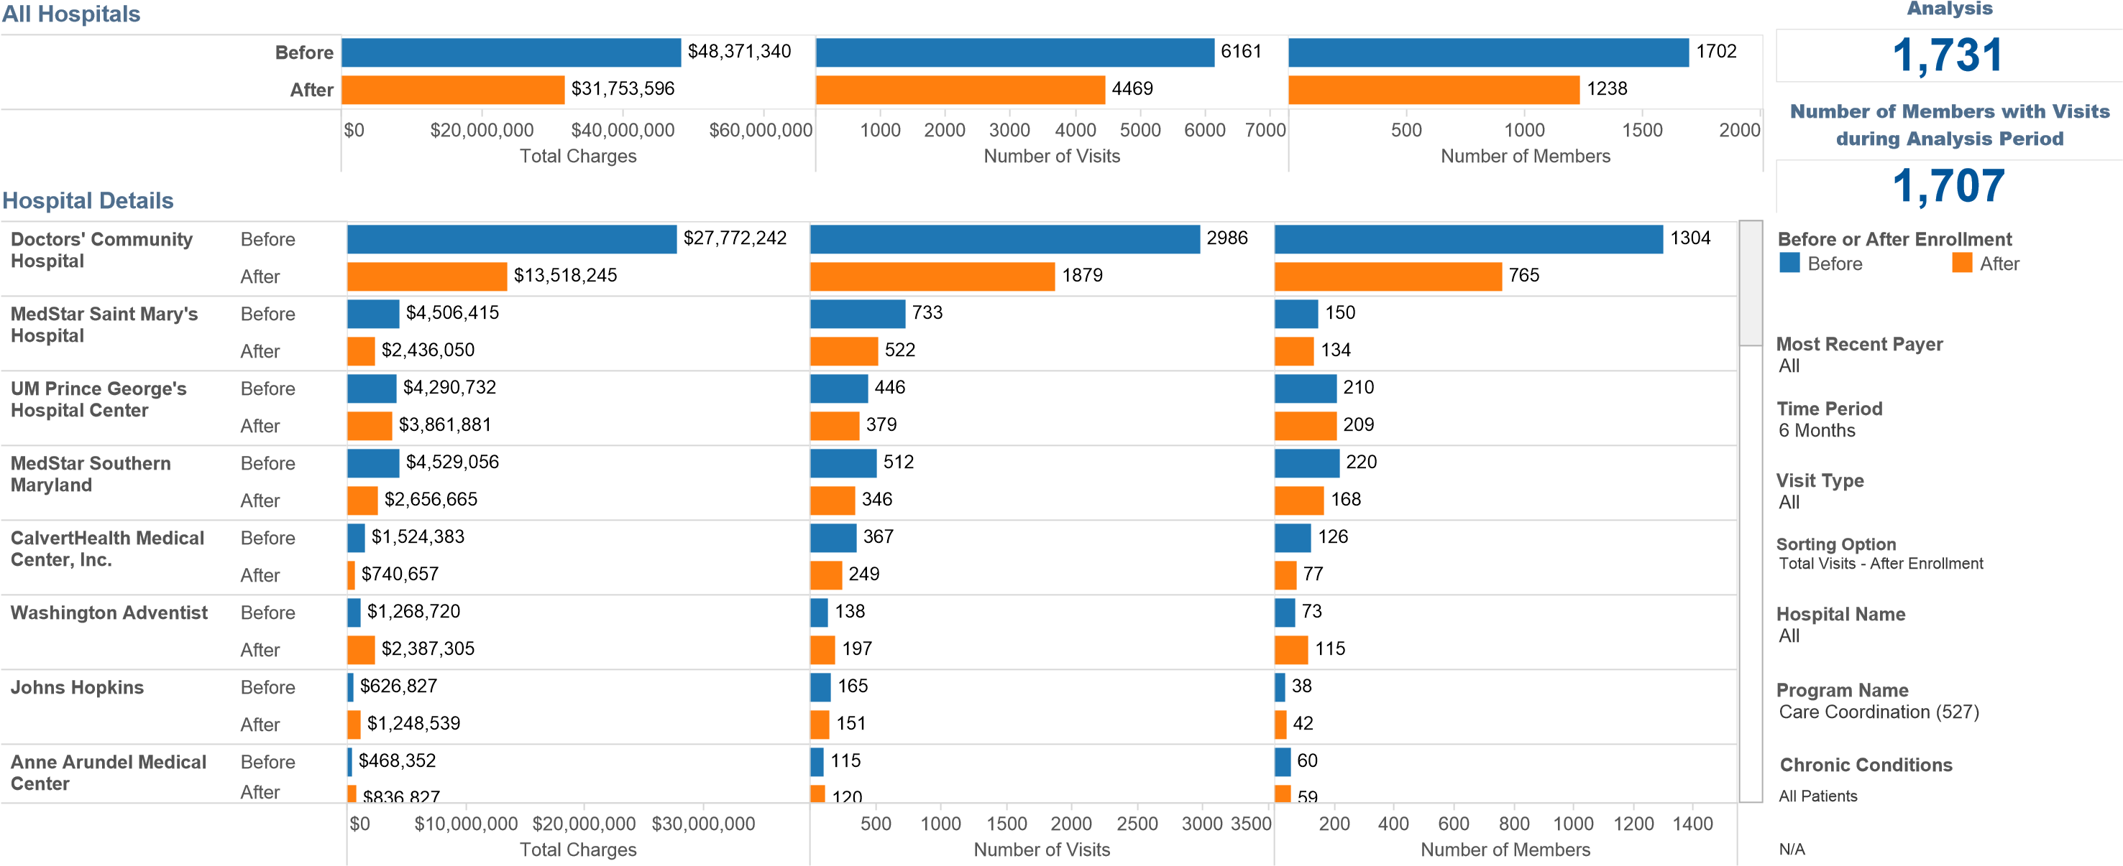

Pre/Post Analysis Breakdown of Charges of 6 Months of Visits Before and After the Enrollment Date **(All Hospitals)**

Most Recent Payer

Visit Type

All

Breakdown of Charges Sheet

Hospital Name

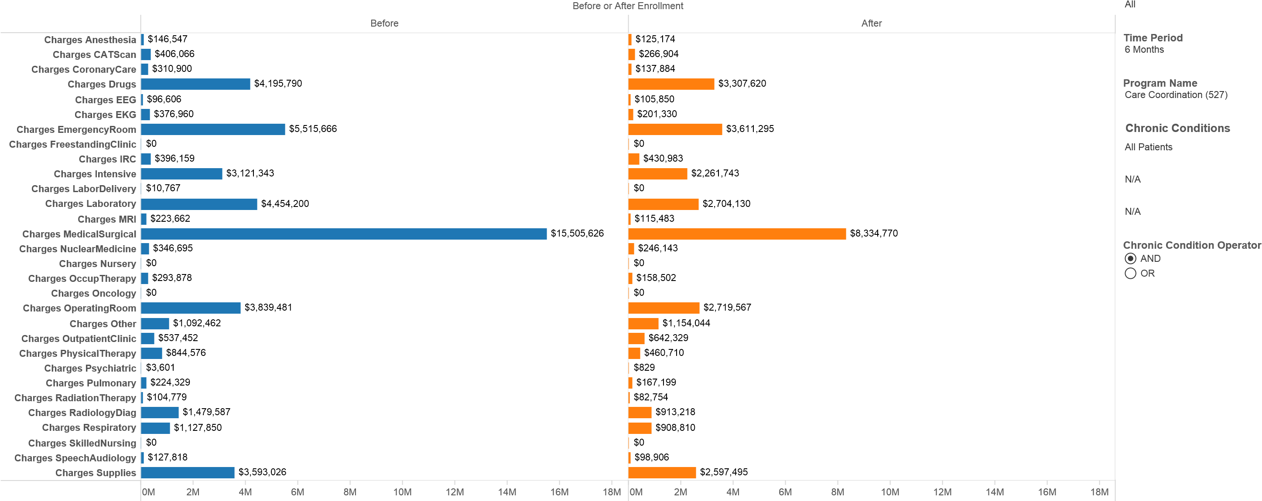

Pre/Post Analysis of 6 Months of Visits Before and After the Enrollment Date **(TLC Only)** **Total Number of Members in the**

**Panel**

|  |
| --- |
| 2,345 |

**Number of Members with Data for**

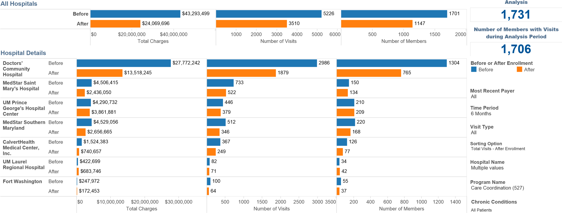

Pre/Post Analysis Breakdown of Charges of 6 Months of Visits Before and After the Enrollment Date **(TLC Only)**

Most Recent Payer

Visit Type

All

Breakdown of Charges Sheet

Hospital Name

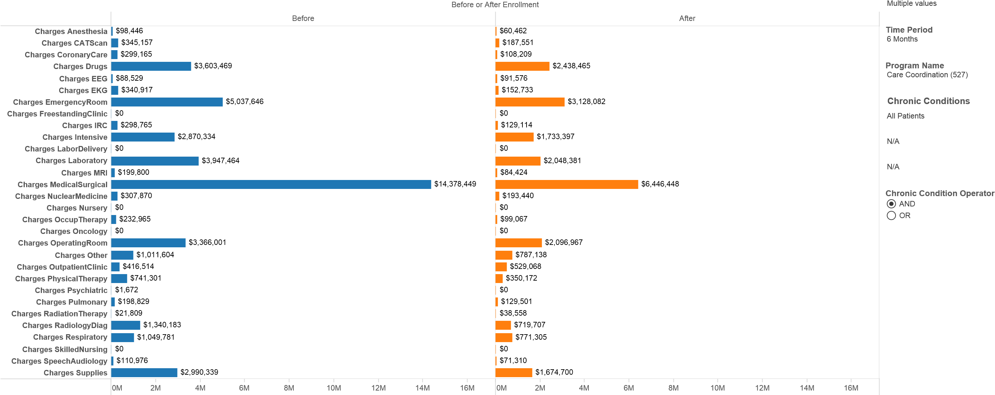

# Addendum 3: HQI Blue Bag Rx Program

Pre/Post Analysis of 6 Months of Visits Before and After the Enrollment Date

**Total Number of Members in the**

**Panel**

|  |
| --- |
| 166 |

**Number of Members with Data for**



All

Breakdown of Charges Sheet

Hospital Name

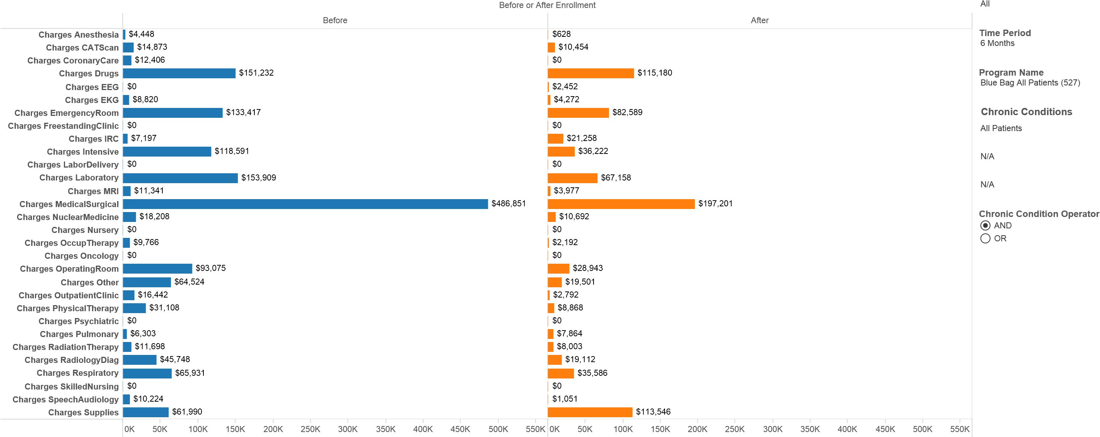

# Addendum 4: P3 Medication Adherence Program

No Pre-Post this reporting period due to lack of full hospital participation in this program.

# Addendum 5: ASA Medication Adherence Tele Health Devices

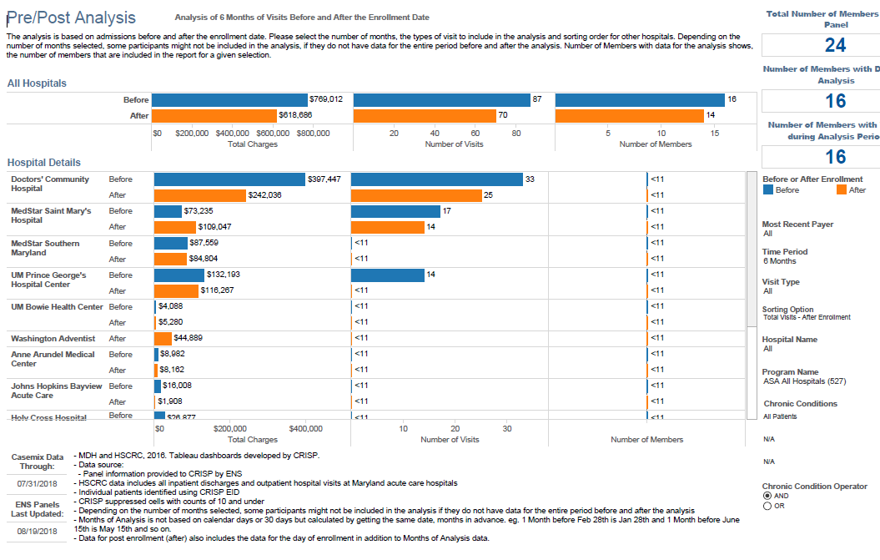

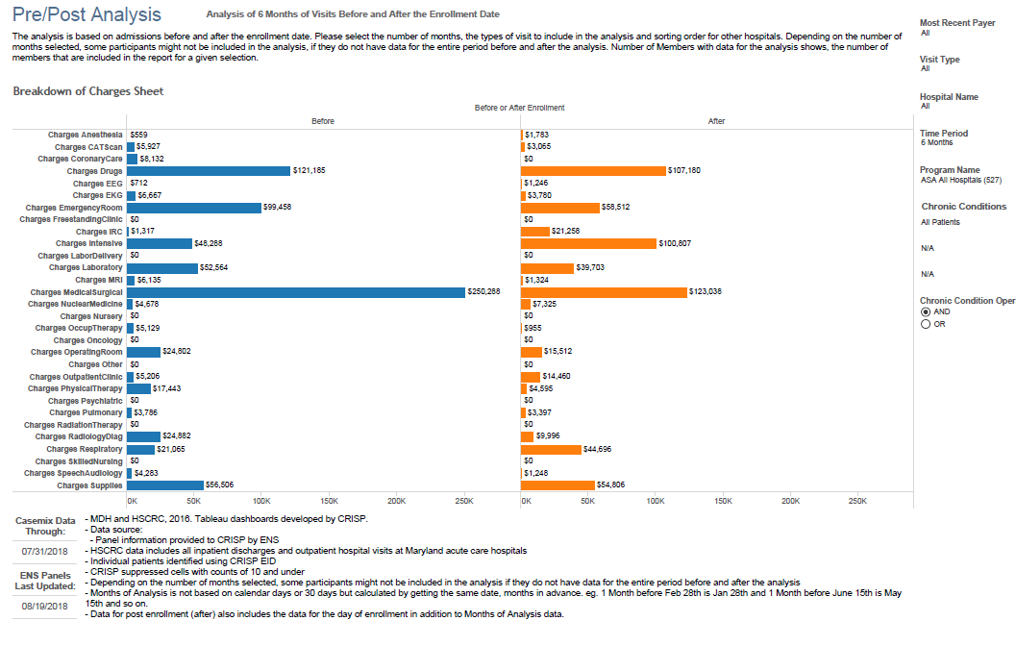

# Addendum 6: Self-Reported Process Measures

**Enrollment Summary: TLC-MD**

**Enrollment Summary: Calvert Memorial Hospital**

**Enrollment Summary: Doctor’s Hospital**

**Enrollment Summary: Fort Washington Hospital**

**Enrollment Summary: Prince Georges Hospital**

**Enrollment Summary: Southern Maryland Hospital**

**Enrollment Summary: St. Mary’s Hospital**

# Addendum 7: Reports under Development:

## 1) Adherence Survey Supporting Logic Model

|  |  |  |  |
| --- | --- | --- | --- |
| **Unique Members: 107** | **Responses** |  |  |
| **Survey Question** | **No** | **Yes** | **Grand Total** |
| Is the patient adherent with their diagnostic plan (lab work/imaging)? | 35 | 73 | 108 |
| Is the patient adherent with their medication plan? | 33 | 76 | 109 |
| Is the patient adherent with their nutrition plan? | 32 | 73 | 105 |
| Is the patient adherent with their PCP appointments? | 46 | 63 | 109 |
| **Grand Total** | **146** | **285** | **431** |
|  |  |  |  |
|  |  |  |  |
|  |  |  |  |
| **Unique Members: 107** | **Responses** |  |  |
| **Hospital** | **No** | **Yes** | **Grand Total** |
| **Calvert Memorial Hospital** | **128** | **85** | **213** |
| Is the patient adherent with their diagnostic plan (lab work/imaging)? | 31 | 23 | 54 |
| Is the patient adherent with their medication plan? | 31 | 23 | 54 |
| Is the patient adherent with their nutrition plan? | 26 | 25 | 51 |
| Is the patient adherent with their PCP appointments? | 40 | 14 | 54 |
| **Doctor's Hospital** | **12** | **144** | **156** |
| Is the patient adherent with their diagnostic plan (lab work/imaging)? | 4 | 35 | 39 |
| Is the patient adherent with their medication plan? | 1 | 38 | 39 |
| Is the patient adherent with their nutrition plan? | 3 | 36 | 39 |
| Is the patient adherent with their PCP appointments? | 4 | 35 | 39 |
| **Fort Washington Hospital** | **1** | **3** | **4** |
| Is the patient adherent with their diagnostic plan (lab work/imaging)? |  | 1 | 1 |
| Is the patient adherent with their medication plan? |  | 1 | 1 |
| Is the patient adherent with their nutrition plan? | 1 |  | 1 |
| Is the patient adherent with their PCP appointments? |  | 1 | 1 |
| **Southern Maryland Hospital** | **1** | **34** | **35** |
| Is the patient adherent with their diagnostic plan (lab work/imaging)? |  | 8 | 8 |
| Is the patient adherent with their medication plan? |  | 9 | 9 |
| Is the patient adherent with their nutrition plan? |  | 9 | 9 |
| Is the patient adherent with their PCP appointments? | 1 | 8 | 9 |
| **St. Mary's Hospital** | **4** | **19** | **23** |
| Is the patient adherent with their diagnostic plan (lab work/imaging)? |  | 6 | 6 |
| Is the patient adherent with their medication plan? | 1 | 5 | 6 |
| Is the patient adherent with their nutrition plan? | 2 | 3 | 5 |
| Is the patient adherent with their PCP appointments? | 1 | 5 | 6 |
| **Grand Total** | **146** | **285** | **431** |

## 2) Vit. D Survey to all patients enrolled

|  |  |  |  |
| --- | --- | --- | --- |
| **Question 1** |  |  |  |
|  | **No** | **Yes** | **Grand Total** |
| **Have you ever had your Vitamin D level checked?** | **111** | **200** | **311** |
|  |  |  |  |
|  |  |  |  |
| **Question 2, if responded "Yes" to Question 1** |  |  |  |
|  | **No** | **Yes** | **Grand Total** |
| **Do you know what the result was?** | **192** | **8** | **200** |
|  |  |  |  |
|  |  |  |  |
| **Question 3, if responded "Yes" to Question 2** | **Responses** |  |  |
| **Enter Vitamin D level** | **8** |  |  |
| does not know value except that it was previously low | 1 |  |  |
| low | 3 |  |  |
| lower than it should have been | 1 |  |  |
| previous reading was low. Not currently taking a supplement | 1 |  |  |
| unk | 1 |  |  |
| unknown number but it was low | 1 |  |  |
|  |  |  |  |
|  |  |  |  |
| **Question 4** |  |  |  |
|  | **No** | **Yes** | **Grand Total** |
| **Are you currently taking Vitamin D?** | **227** | **88** | **315** |
|  |  |  |  |
|  |  |  |  |
| **Question 5, if responded "Yes" to Question 4** | **Responses** |  |  |
| **How much Vitamin D are you taking and how often?** | **86** |  |  |
| 1,000 units daily | 1 |  |  |
| 1,000 units every evening | 1 |  |  |
| 1,000mg daily | 1 |  |  |
| 1.25 weekly | 1 |  |  |
| 1000 IU daily | 2 |  |  |
| 1000 units Daily | 1 |  |  |
| 1000 units daily | 3 |  |  |
| 1000iu/day | 1 |  |  |
| 1000mg daily | 1 |  |  |
| 1000mg or 3000mg a day, something like that, it's in a green bottle | 1 |  |  |
| 1000u BID | 1 |  |  |
| 1200 softgel | 1 |  |  |
| 2 tabs daily, she thinks 1000 units/each | 1 |  |  |
| 2,000 UNITS/DAILY | 1 |  |  |
| 2000 units daily | 2 |  |  |
| 200mg daily | 1 |  |  |
| 400 units daily | 1 |  |  |
| 50 000 IU weekly | 1 |  |  |
| 50 000 u by mouth every week | 1 |  |  |
| 50 000 units once a week | 1 |  |  |
| 50,000 u weekly | 1 |  |  |
| 50,000 units every two weeks | 1 |  |  |
| 50,000 units PO weekly | 1 |  |  |
| 50,000 units weekly | 1 |  |  |
| 50,000 units/week | 1 |  |  |
| 50,000 units/weekly | 1 |  |  |
| 50,000 units/weekly (has 1 dose remaining) | 1 |  |  |
| 500mg D3 every day | 1 |  |  |
| 600 mg daily | 1 |  |  |
| BIW at dialysis; unk dosage | 1 |  |  |
| Calciferol 50,000u monthly | 1 |  |  |
| Calcitriol 0.125 mcg per day Ergocalciferol 50,000 u per week | 1 |  |  |
| Calcitrol one daily | 1 |  |  |
| Calcium 600mg and Vit D 400mg daily | 1 |  |  |
| Calcium Carb with Vit D 800 | 1 |  |  |
| Cholecalciferol 2,00mg per day | 1 |  |  |
| cholecalciferol 5,000u daily | 1 |  |  |
| Citracel + D250mg | 1 |  |  |
| D2 1.25 mg weekly | 1 |  |  |
| D3 1,000 units per day | 1 |  |  |
| D3 1.25 weekly | 1 |  |  |
| D3 2,000 mg per day | 1 |  |  |
| D3 50,000 units per day | 1 |  |  |
| D3 50,000u weekly | 1 |  |  |
| D3 50mcg daily | 1 |  |  |
| Does not know, is over the counter. | 1 |  |  |
| Ergocalcalciferol 1.25 every seven days | 1 |  |  |
| Ergocalceferol unk dose daily | 1 |  |  |
| Ergocalcifritol 50,000 units weekly | 1 |  |  |
| Hematologist monitors lab for member due to the myasthenia gravis. Takes 2000 IU, 1 daily | 1 |  |  |
| I take it on my own ; unk dosage | 1 |  |  |
| Member is pregnant & is taking prenatal vitamins | 1 |  |  |
| Member not taking Vit D supplements at this time. | 1 |  |  |
| Member takes Calcium with Vitamin D daily. | 1 |  |  |
| Member unsure of amount and states prescription is currently being filled at pharmacy. | 1 |  |  |
| multivitamin | 1 |  |  |
| once a week | 1 |  |  |
| Oscal BID | 1 |  |  |
| OTC | 1 |  |  |
| takes calcium + vit D daily | 1 |  |  |
| takes daily, unk dose, member was to have med ready when CC called back but he did not | 1 |  |  |
| Takes it daily. Unsure of dosage. Reports her calcium pills have vitamin D. | 1 |  |  |
| takes weekly | 1 |  |  |
| unknown by member | 1 |  |  |
| Unknown dosage of Vit D every other week | 1 |  |  |
| unknown dose | 1 |  |  |
| unkown | 1 |  |  |
| Unsure of the dosage, takes a daily Vit D supplement as recommended by her MD | 1 |  |  |
| unsure, he receives it at dialysis | 1 |  |  |
| Vit D 5,000 units weekly | 1 |  |  |
| Vit D 50,000u per week | 1 |  |  |
| Vit D2 1.25 weekly | 1 |  |  |
| Vit D2 50,000 units 2xweek | 1 |  |  |
| Vit D2 50,000 Units once per week for 12 weeks. | 1 |  |  |
| Vit D2 50,000u weekly | 1 |  |  |
| Vit D21.25 weekly Vit D3 5,000u daily | 1 |  |  |
| Vit D3 5,000u daily | 1 |  |  |
| Vit D3 500mg daily with calcium | 1 |  |  |
| Vitamin D 10,000 mg daily. | 1 |  |  |
| Vitamin D with calcium twice daily (unable to verify dosage) | 1 |  |  |
| Vitamin D2 50,000u weekly | 1 |  |  |
| Vitamin D3 1000 units po daily | 1 |  |  |

## 3) Short-Term & Long-Term Outcomes Measures

|  |  |  |  |  |  |
| --- | --- | --- | --- | --- | --- |
| **Outcome Measures** | **Outcomes** |  |  |  |  |
| **Type** | **Completed (Follow Up Needed)** | **Not Resolved** | **Partially Resolved** | **Resolved** | **Grand Total** |
| **Mid-Term Outcome Measures** |  | **52** | **2** | **67** | **121** |
| Complete Adherence with Medical Plan Survey |  | 12 | 1 | 35 | 48 |
| Ensure patient has received Vitamin D level screening |  | 11 |  | 23 | 34 |
| Ensure patient is engaged in at least one TLC medication adherence initiative |  | 29 | 1 | 9 | 39 |
| **Short Term Outcome Measures** | **1** | **25** |  | **117** | **143** |
| Ensure patient has coherent eQHealth medical plan | 1 | 6 |  | 51 | 58 |
| Ensure patient has resources to self-manage their care |  | 9 |  | 51 | 60 |
| Perform successful coaching call 5 |  | 10 |  | 15 | 25 |
| **Grand Total** | **1** | **77** | **2** | **184** | **264** |
|  |  |  |  |  |  |
|  |  |  |  |  |  |
|  |  |  |  |  |  |
| **Outcome Measures** | **Outcomes** |  |  |  |  |
| **Type** | **Completed (Follow Up Needed)** | **Not Resolved** | **Partially Resolved** | **Resolved** | **Grand Total** |
| **Calvert Memorial Hospital** | **1** |  |  | **49** | **50** |
| **Mid-Term Outcome Measures** |  |  |  | **8** | **8** |
| Complete Adherence with Medical Plan Survey |  |  |  | 8 | 8 |
| **Short Term Outcome Measures** | **1** |  |  | **41** | **42** |
| Ensure patient has coherent eQHealth medical plan | 1 |  |  | 10 | 11 |
| Ensure patient has resources to self-manage their care |  |  |  | 22 | 22 |
| Perform successful coaching call 5 |  |  |  | 9 | 9 |
| **Doctor's Hospital** |  | **59** | **2** | **67** | **128** |
| **Mid-Term Outcome Measures** |  | **40** | **2** | **22** | **64** |
| Complete Adherence with Medical Plan Survey |  | 9 | 1 | 10 | 20 |
| Ensure patient has received Vitamin D level screening |  | 9 |  | 10 | 19 |
| Ensure patient is engaged in at least one TLC medication adherence initiative |  | 22 | 1 | 2 | 25 |
| **Short Term Outcome Measures** |  | **19** |  | **45** | **64** |
| Ensure patient has coherent eQHealth medical plan |  | 4 |  | 27 | 31 |
| Ensure patient has resources to self-manage their care |  | 7 |  | 15 | 22 |
| Perform successful coaching call 5 |  | 8 |  | 3 | 11 |
| **Fort Washington Hospital** |  | **1** |  | **2** | **3** |
| **Mid-Term Outcome Measures** |  | **1** |  | **1** | **2** |
| Complete Adherence with Medical Plan Survey |  |  |  | 1 | 1 |
| Ensure patient is engaged in at least one TLC medication adherence initiative |  | 1 |  |  | 1 |
| **Short Term Outcome Measures** |  |  |  | **1** | **1** |
| Ensure patient has coherent eQHealth medical plan |  |  |  | 1 | 1 |
| **Prince Georges Hospital** |  | **6** |  |  | **6** |
| **Mid-Term Outcome Measures** |  | **3** |  |  | **3** |
| Complete Adherence with Medical Plan Survey |  | 1 |  |  | 1 |
| Ensure patient has received Vitamin D level screening |  | 1 |  |  | 1 |
| Ensure patient is engaged in at least one TLC medication adherence initiative |  | 1 |  |  | 1 |
| **Short Term Outcome Measures** |  | **3** |  |  | **3** |
| Ensure patient has coherent eQHealth medical plan |  | 1 |  |  | 1 |
| Ensure patient has resources to self-manage their care |  | 1 |  |  | 1 |
| Perform successful coaching call 5 |  | 1 |  |  | 1 |
| **Southern Maryland Hospital** |  | **5** |  | **19** | **24** |
| **Mid-Term Outcome Measures** |  | **5** |  | **8** | **13** |
| Complete Adherence with Medical Plan Survey |  | 1 |  | 4 | 5 |
| Ensure patient has received Vitamin D level screening |  |  |  | 4 | 4 |
| Ensure patient is engaged in at least one TLC medication adherence initiative |  | 4 |  |  | 4 |
| **Short Term Outcome Measures** |  |  |  | **11** | **11** |
| Ensure patient has coherent eQHealth medical plan |  |  |  | 5 | 5 |
| Ensure patient has resources to self-manage their care |  |  |  | 5 | 5 |
| Perform successful coaching call 5 |  |  |  | 1 | 1 |
| **St. Mary's Hospital** |  | **6** |  | **47** | **53** |
| **Mid-Term Outcome Measures** |  | **3** |  | **28** | **31** |
| Complete Adherence with Medical Plan Survey |  | 1 |  | 12 | 13 |
| Ensure patient has received Vitamin D level screening |  | 1 |  | 9 | 10 |
| Ensure patient is engaged in at least one TLC medication adherence initiative |  | 1 |  | 7 | 8 |
| **Short Term Outcome Measures** |  | **3** |  | **19** | **22** |
| Ensure patient has coherent eQHealth medical plan |  | 1 |  | 8 | 9 |
| Ensure patient has resources to self-manage their care |  | 1 |  | 9 | 10 |
| Perform successful coaching call 5 |  | 1 |  | 2 | 3 |
| **Grand Total** | **1** | **77** | **2** | **184** | **264** |